**TEAM PROJECT REPORT**

**Development of a One-Step RNA Virus Detection System**

**Submitted To**

**The RET Site**

**For**

**RET Site on "Challenge-Based Learning and Engineering Design Process Enhanced**

**Research Experiences for Middle and High School In-Service Teachers"**

**Sponsored By**

**The National Science Foundation**

**Grant ID No.: EEC-1404766**

**College of Engineering and Applied Science**

**University Of Cincinnati, Cincinnati, Ohio**

**Prepared By**

**Participant # 1: Elizabeth S. Carlson, Hamilton High School**

**Participant # 2: Eryn J. Ruder, Northwest High School**

**Approved By**

**David Wendell, PhD.**

**Department of Biological, Chemical and Environmental Engineering**

**College of Engineering and Applied Science**

**University of Cincinnati**

**Reporting Period: June 16 – August 1, 2014**

**ABSTRACT:**

Norovirus is responsible for incidences of gastroenteritis worldwide in areas with poor quality drinking water and in places where large numbers of  people are contained in relatively small places. Quick detection of the norovirus can allow for appropriate methods of treatment, sanitation and quarantine.  Using a duplex-specific nuclease (DSN) isolated from the Kamchatka crab, the RNA from the norovirus can be identified using fluorescent-indicators quickly and inexpensively.  This project attempted to improve the single-step RNA virus detection assay by creating three mutated nucleotide sequences which will change the amino acids in the protein of the DSN, so that the indicator is brighter.  Plasmids containing DN, ND and NN mutations were created and confirmed using sequencing analysis, proteins were produced using SHuffle T7 Express *E. coli* and purified in low pH and high imidazole conditions, and enzyme activity tests were run.  This study produced functional, soluble DSN in *E.coli*, as well as three functional DSN mutants which showed greater functionality than the commercial enzyme.  The enzymes produced were active on templates longer than 20 nucleotides, increasing the effective substrate range of native DSN.  This information will be taken back to our classrooms and taught to students using challenge-based learning activities.

**KEY WORDS: norovirus, duplex-specific nuclease, PCR, fluorescent probe, enzyme testing**

1. **INTRODUCTION**

Norovirus is the number one cause of acute gastroenteritis in the United States and is responsible for 20% of gastroenteritis cases worldwide.  It is a highly contagious, RNA based, genetically diverse virus that is spread through person to person contact, contaminated surfaces, and contaminated food and water sources.  As a result of the genetic diversity there are currently no antiviral medications or vaccinations for norovirus.  Surveillance of the virus is the only means of preventing infection.

Outbreaks of norovirus in schools, long-term care facilities, hospitals, and cruise ships illustrate the need for quick norovirus detection in order for sanitation, treatment, and quarantine to take place. However effective, current methods of detection using PCR are time consuming, costly and require specialized equipment.  Duplex-specific Nuclease (DSN) from the Kamchatka crab is the enzyme being investigated for use in a new norovirus detection method.

**2. LITERATURE** **REVIEW**

 First detected in 1972(Farkas 2008), norovirus is now recognized as a leading cause of gastroenteritis globally as well as in the United States.  Studies by the Centers for Disease Control (CDC) indicate that 1 in 10 Americans will contract acute gastroenteritis each year as a result of norovirus infection(Farkas 2008).  This virus is responsible for 25% of pediatric hospitalizations resulting from acute gastroenteritis(Farkas 2008).  Norovirus has been detected in river water, tap water, seawater, and mineral water(Anbazhagi and Kamatchiammal 2010), making it a waterborne pathogen of concern, particularly for developing areas.

Human norovirus is a single-stranded RNA, non-enveloped virus that cannot be grown in cell culture(Schultz 2010; Thorne and Goodfellow 2013). Viral particles range in size from 27-35 nm with an icosahedral capsid containing the 7.3-7.6 kb RNA genome(Katayama, Hansman et al. 2006; Schultz 2010; Thorne and Goodfellow 2013).  Norovirus belongs to the family *Calciviridae* and has over 30 genetic types classified in five genogroups. Of these five genogroups, three infect humans: GI, GII and GIV(Trujillo, McCaustland et al. 2006; Farkas 2008). GII is responsible for most worldwide outbreaks, while infection by GI and GIV are more rare(Schultz 2010).

Norovirus affects all age groups and is responsible for 25% of acute gastroenteritis pediatric hospitalizations.   Studies by the Centers for Disease Control (CDC) indicate that 1 in 10 Americans suffer from acute gastroenteritis caused by the virus yearly(Farkas 2008).  In developing countries, 200,000 deaths of children under age 5 are attributed to norovirus yearly(Thorne and Goodfellow 2013).

     Norovirus has an incubation period on average of 24 to 48 hours, although periods as short as 15 hours have been reported.  Symptoms include acute projectile vomiting, diarrhea, abdominal cramps, nausea, chills, muscle pain, and headache, but does not present with a fever.  The illness persists for 1-3 days in otherwise healthy individuals.  Infants, the elderly, and those with compromised immune systems are more susceptible to severe dehydration as a result of norovirus infections. However, not all infected individuals present symptoms and studies have found virus shedding in 32% of asymptomatic individuals in both volunteer and outbreak studies(Schultz 2010).

Norovirus can be transmitted fecal-oral and person-to-person, both directly and indirectly(Schultz 2010).  The virus is particularly infectious due to both its low infectious dose of 10-100 viral particles(Farkas 2008) and its ability to persist on surfaces for up to several weeks(Schultz 2010).

Due to the low infectious dose, highly sensitive methods are required to accurately detect norovirus contamination.  The standard detection method for norovirus is reverse transcriptase-quantitative PCR (RT-qPCR) which is capable of detecting <10 transcript copies per reaction mixture in GII assay and <100 transcript copies per reaction mixture in GI assay(Trujillo, McCaustland et al. 2006) .  In addition to the time and equipment requirements of this method, it can also be prone to false negatives(Rolfe, Parmar et al. 2007) and require multiple tests to comprehensively test for all norovirus strains(Griffin, Brinkman et al. 2014).  As a result of the genetic diversity of norovirus, no vaccines or antiviral medications are available to effectively treat infections(Farkas 2008), making prevention and detection necessary priorities.

Detection via duplex specific nuclease (DSN), originally from the Kamchatka crab(Anisimova, Rebrikov et al. 2008), provides one possibility for an alternative norovirus detection method.  DSN has previously been used to detect microRNAs(V.E. Anisimova 2006; Anisimova, Rebrikov et al. 2008; Yin, Liu et al. 2012) and could be combined with a fluorescent TaqMan style probe for identification of norovirus in contaminated samples, as shown in Fig.1.  However, DSN is currently costly to produce(Anisimova, Rebrikov et al. 2008) and has an optimal detection length of only 20 nucleotides.  This study aims to develop a mass production method for the enzyme and increase detection efficiency of longer targets through mutation studies of the DNA binding sites.

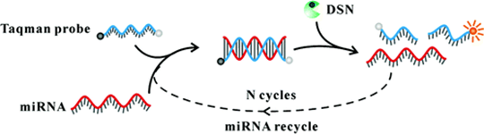

**Figure 1: DSN Cleaves the TaqMan Probe to Produce Fluorescence**

**3. BACKGROUND INFORMATION**

**3.1 The Central Dogma of DNA**

Figure 2 shows the central dogma of molecular biology, which describes the passing of genetic information stored in DNA molecule, through the process of transcription, into an RNA which is delivered to a ribosome which translates the genetic code into a protein.  Deoxyribonucleic acid is composed of a double strand of nucleotides that complement each other (adenine binds to thymine, cytosine binds to guanine) and run in opposite directions, or antiparallel.  In eukaryotes, the DNA is stored in the cell’s nucleus as long linear strands organized into several chromosomes.  Figure 3 shows how, in a prokaryote, the bacterial DNA is organized into a single, circular chromosome, but the cell may contain other circular sequences of DNA called plasmids.

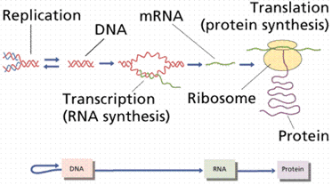 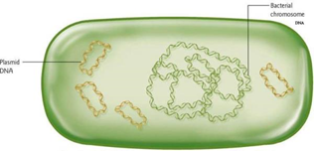

**Figure 2: The Central Dogma of DNA Figure 3: Bacterial Plasmids**

Source: <http://rpdp.net/sciencetips_v2/L12A2.htm> [www.bio.miami.edu/~cmallery/150/gene/mol_gen.htm](http://www.bio.miami.edu/~cmallery/150/gene/mol_gen.htm)

**3.2 Replication of DNA**

DNA replicates using a semi-conservative process, wherein, after unzipping, each strand becomes a template to add new nucleotides.  Figure 4 shows replication beginning when the enzyme helicase opens DNA at an origin of replication, creating a replication bubble.  The strands are held open using single stranded binding proteins as the helicase enzymes move in opposite directions over the strand.  Primase lays down a primer of RNA nucleotides onto the DNA strand, because the enzyme that “builds DNA,” DNA Polymerase III, must have a 3’ end of a nucleotide strand in order to attach new nucleotides.  DNA polymerase will attach to the primer and add complementary DNA nucleotides to the template in the 5’🡪3’ direction at a rate of 1000 nucleotides per second.  On one strand, the new DNA is created as a single continuous strand toward the replication fork.  On the opposite strand, which is antiparallel to the first, new DNA is created as a series of Okazaki fragments away from the replication fork, using additional RNA primers that are laid down as the DNA is opened further.  As the DNA is unwound further, topoisomerase will prevent over-twisting of the strand.  The primers are removed by DNA polymerase I and segments of DNA are attached to each other using the enzyme ligase.

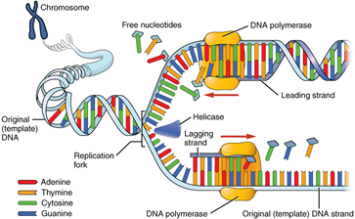

**Figure 4: Replication of DNA**

Source:  <http://cnx.org/content/m46073/latest/>

**3.3 Transcription**

When a gene is ready to be expressed, DNA is used as a template to create a single strand of messenger RNA (mRNA).  Figure 5 shows how RNA polymerase will attach to the DNA at the promoter sequence upstream of the gene sequence that will be translated to mRNA.  RNA polymerase then unzips the DNA, creating a transcription bubble that is 17 base pairs long, and adds RNA nucleotides complementary to the template strand of DNA.    RNA polymerase adds nucleotides more slowly than DNA polymerase, at a rate of 30 nucleotides per second, and makes more mistakes, so transcription has lower fidelity than DNA replication.  Also RNA polymerase is less processive than DNA polymerase, so it will add fewer nucleotides to its template before releasing.  Transcription continues until the RNA polymerase reaches the termination sequence on the DNA template.  At this point, the polymerase will release from both the DNA and the new mRNA strand using either an unassisted method, involving the creation of a hairpin loop in the mRNA strand, or assisted termination, using Rho helicase to pull the strands away from the polymerase.  In prokaryotes, the mRNA produced does not need to be processed before being translated into proteins.

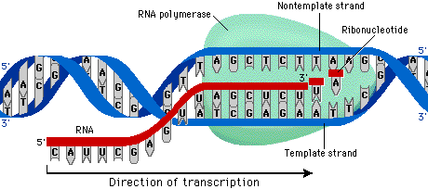

**Figure 5:** **Transcription—Production of mRNA**

Source:  <http://www.phschool.com/science/biology_place/biocoach/transcription/tcproc.html>

**3.4 Translation**

Translation is the process that occurs at the ribosome in the cytoplasm in which the code from an mRNA strand is decoded and used to create a polypeptide strand. The process is shown in Fig. 6.  In prokaryotes, as an mRNA strand is created during transcription, ribosomes will attach at the initiation sequence at the 5’ end of the mRNA.  First, the small subunit of the ribosome will bind to the mRNA with the start codon, AUG, available for the transfer RNA (tRNA) with the correct anti-codon (UAC) and amino acid (methionine) to adhere.  This allows the large subunit of the ribosome to attach to the initiation complex and begin the elongation sequence of translation.  Elongation takes place as the ribosome moves down the mRNA, helps the correct tRNA to bind with the mRNA, and facilitates the formation of peptide binds between the amino acids carried in by the tRNA.  The order of the amino acid sequence is determined by the order of nucleotides/codons on the mRNA strand.  Translation will continue until the ribosome reaches one of three “stop” codons, which signals the ribosome and polypeptide strand to release from the mRNA.

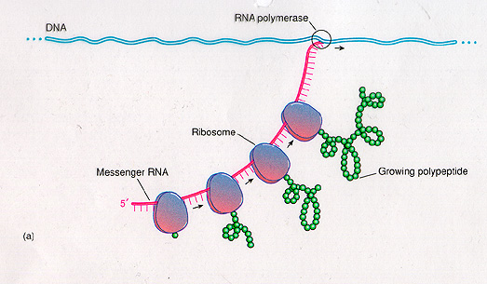

**Figure 6: Translation: Protein Synthesis**

Source:<http://www.bio.miami.edu/dana/250/250F12_8.html>

**3.5 Prokaryotic Pre-Transcription Controls/*Lac* Operon**

Many genes’ expression is controlled through the use of repressor enzymes, which prevent RNA polymerase from attaching to DNA at the promoter sequence.  Because the polymerase is blocked, it cannot produce copies of mRNA to be used by ribosomes to produce proteins.  One of these regulation systems uses the *Lac* operon, shown in Fig. 7.  Bacteria have a set of genes for the enzymes that digest lactose.  Because lactose is not a common sugar in the bacteria’s environment, it is more efficient for that gene to be turned off when lactose is unavailable and only switched on when lactose is present.  This works because there is a repressor protein that attaches to the DNA near the promoter sequence, which is upstream of the genes that would be transcribed.  When lactose enters the bacteria, it attaches to the repressor, which causes its shape to change and release from the DNA.  When the repressor is removed from the DNA, RNA polymerase attaches to the promoter and transcribes mRNA.  This allows the necessary proteins to be produced to digest the lactose.  When the concentration of lactose decreases enough, the repressor reattaches to the DNA, halting transcription until lactose is present again.  This is important to this research because during protein production, transcription will be ‘turned on’ using the *Lac* operon.  Rather than inducing transcription with the addition of lactose, which would be digested by the *E.coli* and need to be readded to the mixture, IPTG, which is structurally similar to lactose, but is not metabolized by the cells, will induce protein production by removing the repressor from the DNA strand.

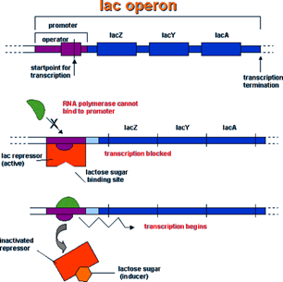

**Figure 7: The *Lac* Operon**

Source: <http://abenagh.pbworks.com/w/page/32424238/Group%20Free%20Response%203>(%3A

**3.6 Procedures used in this research**

This research project created mutations in the DNA sequence that codes for the duplex-specific nuclease (DSN), an enzyme purified from the hepatopancreas of the Kamchatka crab.  To achieve this, mutated gene sequences were created via PCR and the resulting proteins were purified using affinity chromatography.

Polymerase chain reaction (PCR) is a process used to amplify or make copies of specific sequences of DNA.  PCR is ‘primer driven,’ which means that primers are designed to frame the desired sequence of DNA on each of the two antiparallel strands.  The primers are short sequences, typically 18-30 base pairs in length, and complement the bases at the 5’ ends of the desired sequence of DNA.   This allows only the base pairs in between the primers to be copied from the original template DNA.  Usually this is a relatively short sequence of DNA, as the longer the target strand, the less efficiently it will be created.

The amplification process of PCR is a three-step cycle, with each step occurring at a different temperature.  The PCR mix, containing template DNA, primer, buffer solutions, catalyst, nucleotides and thermostable DNA polymerase, is put into a thermal cycler to run between 20-50 amplification cycles.  The stages of PCR include a) denaturation, at 90-98 ˚C, which separates the two strands of target DNA and activates the polymerase enzymes; b) annealing, at 40-68 ˚C, the binding of primers to the DNA template; and c) extension, at 68-75 ˚C, when the polymerase replicates the DNA.  The product of PCR is called the amplicon, and the amount of amplicon should be equal to 2N, where N equals the number of cycles.

A modified site-directed mutagenesis PCR method was used to produce the mutated DNA sequences.  Traditional site-directed mutagenesis is effective for small sequence changes up to about 10 base pairs; however, the efficiency declines as the length of the mutated sequence increases.  This approach is good for small changes in DNA, with a maximum alteration of 10 base pairs.  In this approach, overlapping primers are designed that substitute only a few nucleotides, but are complementary to the original on both sides of the mutation.  Because most of the base pairs are “correct,” the primer binds to the template DNA, even with the mutation.  PCR is used to amplify the sequence to produce a significant amount of mutated DNA sequences.

A sample of this product is run across an agarose gel using electrophoresis.  Because DNA is negatively charged, applying a positive charge to the opposite end of the gel will pull the DNA across the gel, with shorter strands of DNA migrating faster than longer strands. Electrophoresis will show the relative weight of the product and, to a lesser extent, the amount of product produced.

As shown in Fig. 8, this mutated sequence is then inserted into a plasmid vector using restriction enzymes to cut DNA, insert the mutated sequence into the plasmid, and then ligase rejoins the DNA strand into a circular strand. After the process is complete, the sample is “cleaned” using a series of buffers and enzymes.  Upon confirmation of amplicon length, Dpn1, an endonuclease, is used to remove the methylated template DNA, so that the DNA in the final product is only the desired mutated sequence.  An enzyme mix was used to join the mutated plasmid, which is then introduced to bacterial cells using the process of transformation.   The plasmid often contains the gene for antibiotic resistance at another location in the DNA, to allow the growth of bacterial colonies in media containing the antibiotic, preventing growth of bacteria that does not have the mutation.

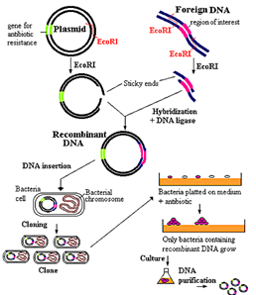

**Figure 8: Inserting a Mutated Sequence into a Plasmid**

**3.7 Current Detection Methods**

Currently, virus detection methods use a process called real-time or quantitative PCR (qPCR), which is costly because it requires both time and specialized equipment.  To detect the presence of a virus, water samples are mixed with a fluorescent detector.  The PCR process amplifies or makes copies of the viral DNA or RNA, while the machine also activates the fluorescence with light and a camera takes a picture of the signal.   PCR occurs in three phases: the exponential phase, when there is a small sample size and excess of probes and/or primers, so the amount of PCR product doubles with each cycle; the linear phase, when reagents begin to run out, so the reaction slows; and the plateau phase, when reagents are depleted and the reaction stops.  qPCR focuses on the exponential phase and measures the number of cycles it takes to reach the threshold fluorescence level.  Figure 9 demonstrates how the length of time it takes to reach the cycle threshold level (Ct), or lag phase, is inversely proportional to the amount of starting material added to the reaction.  So, the length of the lag phase can be used to back calculate the number of viral particles in the sample.

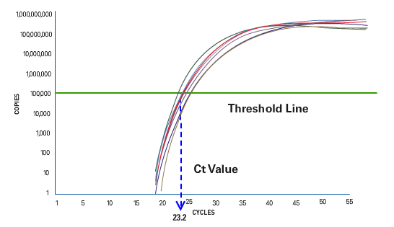 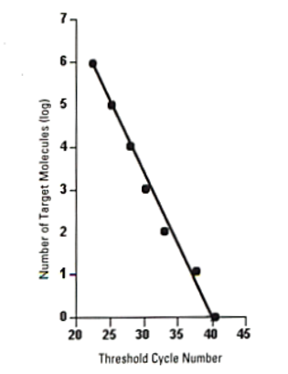

**Figure 9: Using the Cycle Threshold Level to Back-Calculate Number of Starting Molecules**

Source: <http://media.invitrogen.com.edgesuite.net/ab/applications-technologies/real-time-pcr/real-time-polymerase-chain-reaction/index.html>

qPCR uses two main strategies to mark target DNA or RNA.  The first uses SyBr Green dye, a non-specific method of marking DNA, because it will bind to the minor groove of any DNA sample.  The amount of green light emitted by the dye/DNA complex will be recorded.  When running this reaction, it is important to determine the melting temperature of the sample DNA to determine that the desired amplicon was produced.  As shown in Fig. 10, if there were other DNA contaminants or primer dimers present, they would show up as alternate peaks on the detection graph.

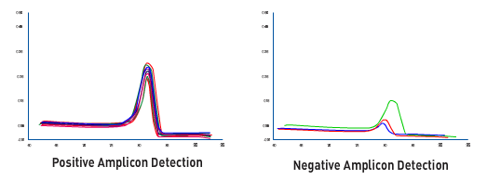

**Figure 10: Determining the Melting Temperature of Sample DNA**

Source: <http://media.invitrogen.com.edgesuite.net/ab/applications-technologies/real-time-pcr/real-time-polymerase-chain-reaction/index.html>

The second, and more specific, strategy that can be used with qPCR involves the use of sequence-specific TaqMan probes or molecular beacons, shown in Fig. 11.  Each of these binds with specific nucleotide sequences if they are present in the water sample.  TaqMan probes have a fluorescent reporter on one end and a quencher molecule on the other.  If these two molecules are in close proximity, the quencher prevents the reporter from glowing.  The probe binds to the target sequence.  When the polymerase adds nucleotides to the target, it removes and splits the probe, separating the reporter from the quencher, so that a fluorescent signal is observed.  Molecular beacons also have a reporter and quencher on each end of the molecule, but differs because the sequence of nucleotides between the two tags arrange themselves in a hairpin shape.  When the molecule is unbound, the reporter and quencher are right next to each other, so the reporter does not fluoresce.  When the correct complementary target sequence is found, the molecule extends to a linear form and binds to the molecule.  This increases the distance between the reporter and quencher, so the signal glows.

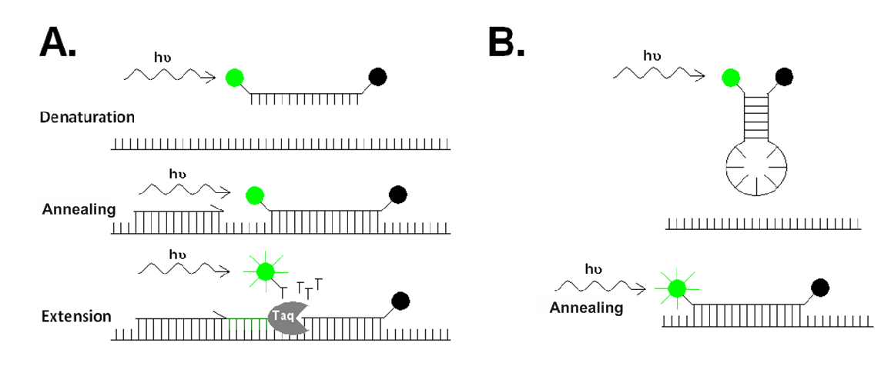

**Figure 11: Using TaqMan Probes & Molecular Beacons for Signaling**

Source: <http://www.eligene.com/download/cms/images/7-1321967304.png>

**4. GOALS AND OBJECTIVES**

The goal of this project was to improve the single-step RNA virus detection assay, by creating three mutated plasmids which would change the amino acids in the protein of the DSN and result in a change in enzyme activity.  It was believed that changing the amino acids in the DSN protein would result in improved enzyme activity. Quick detection of the norovirus can allow for appropriate methods of treatment, sanitation and quarantine to be readily implemented.  A long term goal is to provide public health officials with a “Norovirus Identification Kit” containing a packet of enzymes and a packet of probes, allowing them to remove the need for qPCR completely.

**5. RESEARCH STUDY DETAILS**

**5.1 Plasmid Production**

All chemicals were purchased from Sigma Aldrich (St. Louis, MO) unless otherwise specified. The DSN mutants D362N (DN), D361N (ND) and D361N,D362N (NN) were produced via PCR using 2X CloneAmp HiFi MasterMix (Clontech Laboratories, Mountain View, CA).  Plasmid creation was completed using 5X Infusion HD Enzyme Premix (Clontech Laboratories, Mountain View, CA).  Mutations were confirmed by sequencing analysis.

**5.2  Protein Production**

SHuffle T7 Express Competent *E. coli* (NEB, Ipswich, MA) were used for protein production and proper folding was facilitated by addition of a self-cleaving N-terminal TRX-intein tag(Yang, Marinakos et al. 2011).  Protein expression was done in Overnight Express Instant LB Medium (EMD Millipore, Billerica, MA) at 30oC.  Proteins were purified using affinity chromatography via an N-terminal 6X His tag.  Briefly, cells were harvested by centrifugation at 12,000g and resuspended in a buffer containing 50mM Tris and 300mM NaCl, pH 7.8.  Cells were lysed via French press and centrifuged at 30,000g to collect debris.  The resulting supernatant was applied to His60 Superflow Resin (Clontech Laboratories, Mountain View, CA) and washed with a buffer containing 50mM Tris, 300mM NaCl, and 40mM imidazole, pH 7.8.  The first elution was taken after an incubation of one hour at room temperature in a buffer of 50mM Tris, 300mM NaCl, 10mM MgCl2, and 1mM DTT, pH 6.0. The remainder of the protein was eluted using a buffer of 50mM Tris, 300mM NaCl, and 500mM imidazole, pH 7.8.  Protein production was confirmed by SDS-PAGE gel.  Before use, protein fractions were dialyzed into a buffer of 50mM Tris, 300mM NaCl and 10mM MgCl2, pH 6.7.

**5.3  Enzyme Testing**

Enzymatic activity tests were performed in a 30μL volume containing a buffer of 50mM Tris, 300mM NaCl and 10mM MgCl2, pH 6.7, 50nM DNA probe and either 12.5, 25, 50, or 100nM mock RNA norovirus template. Sequences for oligonucleotides used in enzyme testing are shown in Table 1.  Seawater was sourced from Boothbay Harbor (National Center for Marine Algae and Biota, East Boothbay, ME) and river water was source from Little Duck Creek (Duck Creek Watershed, Cincinnati, OH).  Reactions were incubated at either 37oC for 40 minutes or 60oC for 30 minutes.  Fluorescence of the 6-FAM probe was monitored in the FlexStation3 plate reader (Molecular Devices, Carlsbad, CA) using an excitation of 495nm and an emission of 520nm with an excitation cutoff of 515nm.

**Table 1. Sequences of oligonucleotides used in enzyme testing.**

|  |  |
| --- | --- |
| **Sequence Name** | **Sequence (5'-3')** |
| NoroGen2RNATemp | UGUGAAUGAAGAUGGCGUCGAAUG |
| NoroGen2DNAProbe | [6-FAM]-TCGACGCCATCTTCATTC-[BHQ-6-FAM] |

**6. RESEARCH RESULTS**

Plasmids containing the DN, ND, and NN mutations were successfully created and confirmed via sequencing analysis shown in Figure 12.  The original TRX-intein tagged DSN protein and the mutated proteins were overexpressed in SHuffle T7 Express Competent *E. coli.*The combination of the TRX tag and the SHuffle T7 Express *E. coli* likely helped produce soluble protein, while previous attempts to express functional protein in *E. coli* have resulted in inclusion body formation(Anisimova, Rebrikov et al. 2008). Purity of the eluted protein was confirmed by SDS-PAGE gel, shown in Figure 13.  The imidazole elution fraction yielded a larger quantity of protein than the low pH elution and both fractions contained cleaved and uncleaved DSN.  All *E. coli* produced proteins were dialyzed into a Tris based buffer containing MgCl2, pH 6.7 before use.







**Figure 12:  Sequenced DN (top), ND (middle), and NN (bottom) Mutations**

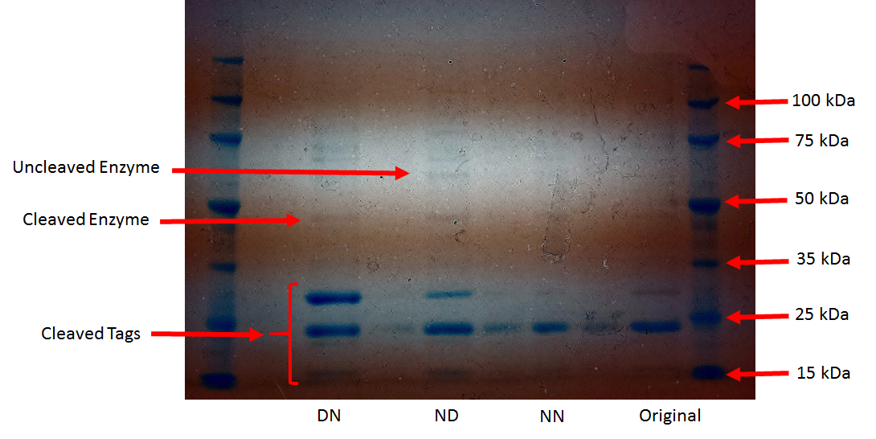

**Figure 13: SDS-PAGE gel analysis of purified DSN. The first and last columns are markers, the 2nd and 3rd columns are the DN mutant under low pH and high imidazole elution conditions, respectively, the 4th and 5th columns are the ND mutant under low pH and high imidazole elution conditions, respectively, the 6th and 7th columns are the NN mutant under low pH and high imidazole elution conditions, respectively, and the 8th and 9th columns are the original enzyme under low pH and high imidazole elution conditions, respectively.**

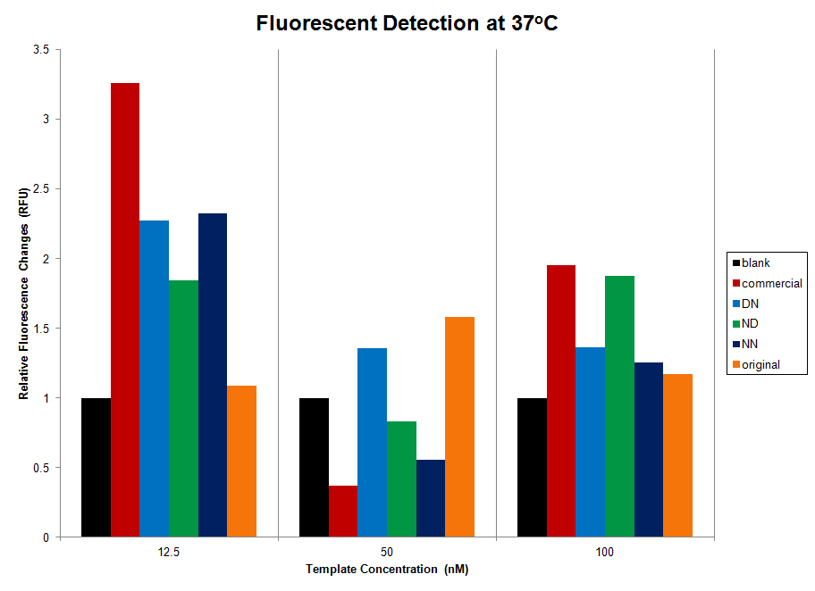

**Figure 14. Relative Fluorescent Changes for all enzymes produced in E. coli, the commercial DSN enzyme, and a buffer blank in tests performed at 37oC. All tests were performed in triplicate.**

Preliminary enzyme testing was done to determine an appropriate buffer for activity tests. As a result, a Tris based buffer containing MgCl2 at pH 6.7 was used for all further tests (data not shown).   All enzymes tested showed varying levels of detection when tested at 37oC, a temperature much lower than the optimum 60oC for DSN function, shown in Figure 14. The in-house produced original DSN enzyme and the DN mutant identified the RNA template at all concentrations.  A mock genome concentration of 12.5nM was found to result in the most fluorescent signal for all enzymes with the exception of the original DSN, which produced the largest signal at 50nM mock template.  Interestingly, none of the enzymes show increased signal with increased RNA mock genome concentrations; rather, some show an overall trend of increased signal with decreasing mock genome concentrations.  The ND and NN mutants show a similar pattern to the commercial enzyme at 37oC, indicating that these mutants retain some of the characteristics of the commercial enzyme.

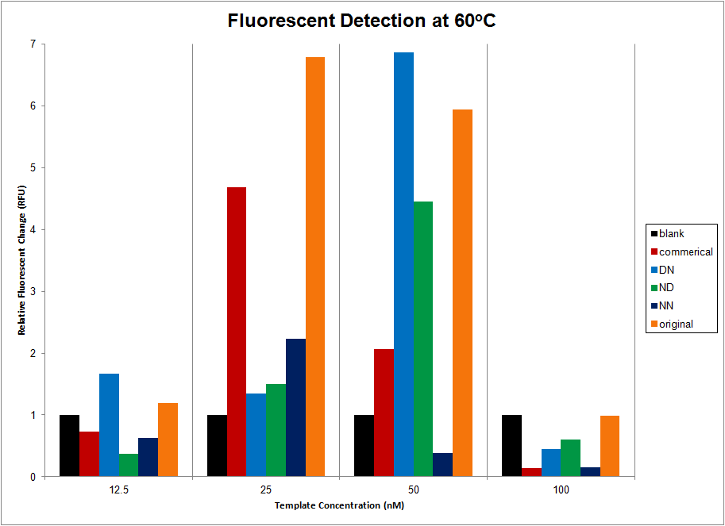

**Figure 15. Relative Fluorescent Changes for all enzymes produced in E. coli, the commercial DSN enzyme, and a buffer blank in tests performed at 60oC. All tests were performed in triplicate.**

Enzyme activity testing was also done at 60oC to examine the activity of the mutants at optimal enzyme temperature, shown in Figure 15.  Overall, these tests showed higher signals than those performed at 37oC, indicating that detection can be improved by increasing the temperature.  Only the DN mutant was able to detect mock norovirus RNA template at a concentration of 12.5nM, while none of the tested enzymes successfully identified the template at a concentration of 100nM.  This could indicate an inhibition of the enzyme at high RNA concentrations as well as the existence of an optimal range for detection between 12.5 and 100nM.  The DN and ND mutants, as well as the in-house produced original enzyme, out-performed the commercial enzyme by over 4, 2, and 3 relative fluorescent units (RFUs), respectively, suggesting that production in *E. coli* may have a beneficial impact on enzyme function.

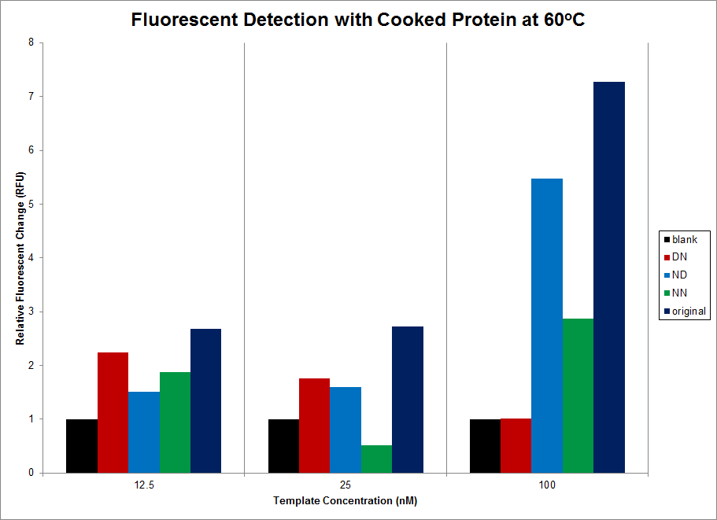

**Figure 16. Relative Fluorescent Changes for all enzymes produced in E. coli and a buffer blank in tests performed at 60oC. Enzymes were pre-cooked at 60oC for 10 minutes before testing. All tests were performed in triplicate.**

To test the thermostability of the *E. coli* produced enzymes, protein fractions were pre-heated at 60oC for 10 minutes before addition to the activity assays, also conducted at 60oC, shown in Figure 16.  The commercial enzyme was not tested, as it has already been found to be thermostable.  All of the tested enzymes detected the presence of the mock RNA template with the exception of NN at 25nM template.  Removing the non-thermostable material present had the most negative impact on NN and the in-house produced original enzyme at 25nM mock RNA genome.  Additionally, the pre-cooked material generally showed increased fluorescence values with increasing mock template concentration. Overall, removing the non-thermostable material improved detection, particularly for the 100nM template, indicating that the functional enzyme produced is indeed thermostable.

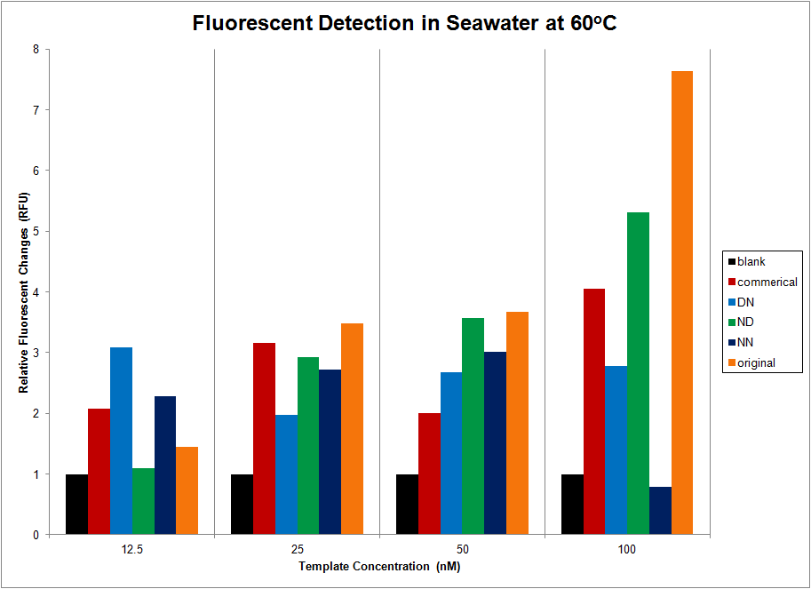

**Figure 17. Relative Fluorescent Changes for all enzymes produced in E. coli, the commercial DSN enzyme, and a buffer blank in tests performed in seawater at 60oC. All tests were performed in triplicate.**

To explore the limits of enzyme activity, assays were also conducted in seawater and river water at 60oC.  In the presence of seawater, all enzymes were able to detect mock RNA template with the exception of the NN mutant at 100nM mock genome, shown in Figure 17.  In general, all enzymes showed increased fluorescence values with increasing mock template from 12.5nM to 100nM with the exception of the ND mutant that remained relatively constant and the NN mutant, which decreased to below the detection limit.  All of the *E. coli* produced enzymes showed more fluorescent signal than the commercial enzyme at a mock template concentration of 50nM and the ND mutant and in-house produced original enzyme out-performed the commercial enzyme at 100nM mock template.

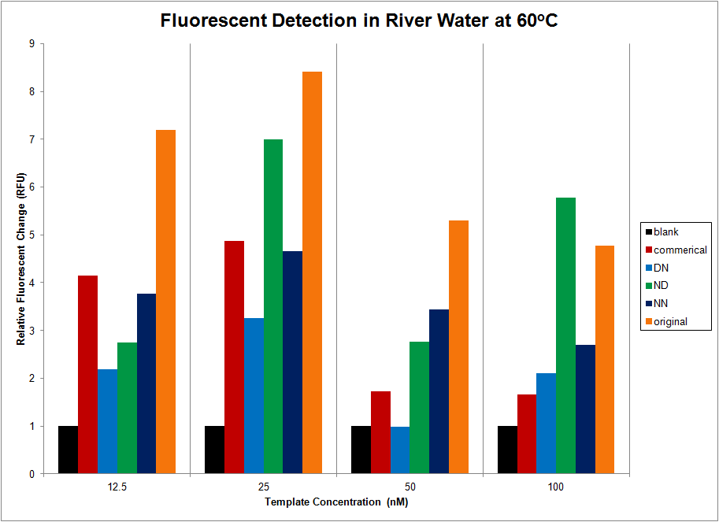

**Figure 18. Relative Fluorescent Changes for all enzymes produced in E. coli, the commercial DSN enzyme, and a buffer blank in tests performed in river water at 60oC. All tests were performed in triplicate.**

Assays conducted in river water samples showed overall improved fluorescence values for 12.5nM, 25nM, and 100nM mock RNA template compared to assays conducted in nanopure water, shown in Figure 18.  Similar to other assays, fluorescent values decreased with increasing values of mock RNA norovirus genome. The in-house produced original enzyme outperformed the commercial enzyme for all concentrations of mock RNA template and the ND mutant performed best compared to the commercial enzyme at all template concentrations except for 12.5nM. The ND mutant also showed more fluorescent signal than the in-house produced enzyme at a mock RNA template concentration of 100nM.

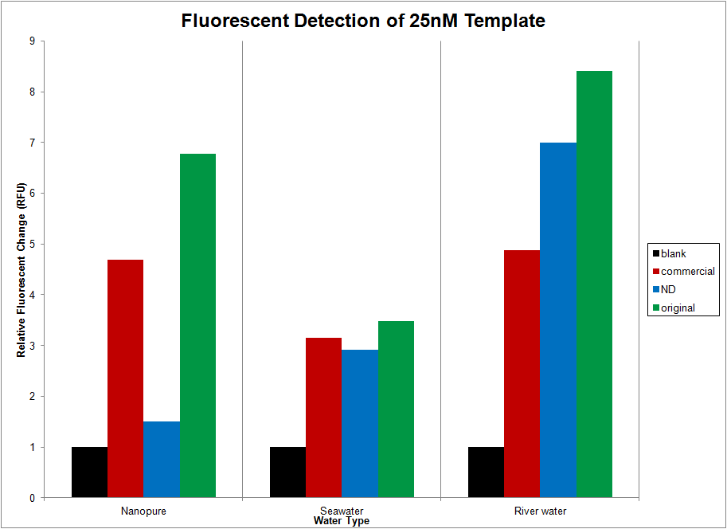

**Figure 19. Relative Fluorescent Changes for the in-house produced original DSN enzyme, the ND mutant, the commercial DSN enzyme, and a buffer blank in tests performed in nanopure water, seawater, and river water at 60oC. All tests were performed in triplicate.**

The performance of the commercial enzyme, the ND mutant, and in-house produced original enzyme in nanopure water, seawater, and river water are shown in Figure 19. The in-house produced original enzyme provides higher fluorescent values than the commercial enzyme in all types of water tested. The ND mutant shows the most fluorescent signal in river water, also the only medium in which it produces more signal than the commercial enzyme.

**7. RESEARCH CONCLUSIONS**

This study demonstrates the first reported production of functional, soluble DSN in *E. coli*, facilitated by addition of an N-terminal TRX tag and expression in SHuffle competent cells. Cleavage of the N-terminal tags was observed in all DSN variants produced. All DSN mutants produced, DN, ND, and NN, were found to be thermostable with functionality at 60oC and limited functionality at 37oC. All *E. coli* produced enzymes retained some degree of functionality in nanopure water, seawater, and river water. The ND mutant was found to be the best performing mutant, in some cases producing more fluorescent signal than the commercial enzyme. Finally, the enzymes produced in this study were active on templates longer than 20 nucleotides, increasing the effective substrate range of native DSN.

**8. RECOMMENDATIONS FOR FUTURE RESEARCH**

Future research on this project should continue on two main tracks. The first direction will focus mainly on structural properties of the DSN mutants to determine how the mutations impact protein folding. These studies should be done using all three mutants as well as the in-house produced original enzyme and include crystallography, nuclear magnetic resonance, and circular dichroism studies to determine the 3D structure of each mutant. The second direction for future research will focus on examining the detection limits of each enzyme. This will include determining both the upper and lower limits of detection for the enzyme. Additionally, the effective substrate length of the enzymes will be tested to determine the optimal conditions for detection of the complete norovirus genome.

**9. CLASSROOM IMPLEMENTATION PLANS**

**9.1 Elizabeth Carlson’s Classroom Implementation Plan**

Elizabeth Carlson’s unit is titled “Water, Water Everywhere…”  It will be used in 4 sections of tenth grade Honors Biology beginning in the first month of the 2014-2015 school year.  The big idea is that all people need access to safe drinkable water--780 million lack access to clean water and 3.4 million die from water related diseases each year.  Cheap and efficient methods of water purification need to be developed to give access to safe water sources to people without, due to socio-economic conditions in third-world countries, human error, including chemical spills into water, or natural disasters, including hurricanes, earthquakes and floods.  The essential question students will address is “How can contaminated water be made safe to drink?”

To address this essential question, students will be given the challenge of designing a self-contained, handheld water purification process that uses two of the teacher-provided filtration materials, with one additional filtering material brought from home, to clean 500 ml of river water, contaminated with a harmless bacteria, within 5 minutes. The filter should remove color, odor and biotic and abiotic particles from the water.  The pH should be increased to 7-8.  Filtered water will be tested for color, odor, turbidity, pH and presence of ions in the water, including chlorine, nitrates and nitrites.  A bacterial culture of the water will be grown, as well.  Students will have the opportunity to redesign and retest their filters.

The guiding questions for this challenge include:  What could be in the water making it unsafe to drink?  Are there living or non-living things in contaminated water?  What methods can be used to remove visible particles from water?  Does removing just the visible (big) particles make water “clean?”  Why do we need water?  How much water does a person need each day?  What living/nonliving things can be in contaminated water and make people sick?  What causes water to become contaminated?  What diseases can people get from drinking contaminated water?

This unit was selected because in the past, test scores and writing samples have shown that students struggle with the chemistry of life, including water, ions, proteins/enzymes and the differences between bacteria & viruses.  Understanding that water sources have not only visible, but microscopic or dissolved substances in it, is a common problem.  Students often assume that tap water is “pure” water, rather than it is “safe” or “potable” water.  Using hands-on, physical methods to remove materials from water will help them understand what may or may not be present in sources of drinking water sources.

In Lesson one, “The Importance of Water,” students will be exposed to the reality of people who don’t have access to drinking water, then learn the properties of water that make it a vital component of life on Earth.  Activity one will introduce the Big Idea, Generate the Essential Question, and formulate Guiding Questions.  It will begin with showing the video from the Zambia Project website, ”World Vision water: Meet Violet and the other children of the Zambia Project” and a news story about the West Virginia chemical spill in January, 2014.  These two videos should demonstrate the global relevance of the need for safe drinking water.  Lesson two, “Properties of water,” for each property of water (adhesion/cohesion, surface tension, pH, solubility, density), a hands-on activity will be performed and observed, with a discussion of the concept demonstrated afterward.  Students will research how each of water’s properties impacts life on Earth.

Lesson two, “Water filtration,” will provide students the opportunity to experiment with water filtration materials and use resulting information to design a kit to clean contaminated water.  During activity three, “Filter tests,” small groups of students will test properties of different combinations of three filter materials and its ability to filter “grey water,” and report the results of their combination of materials to the whole class.  For the culminating activity, activity four, “The Challenge,” teams of students will use what they learned about water filtration materials in activity three to design a handheld water filtration process that uses up to three materials to clean 500 ml of contaminated water within 5 minutes.  They will try to improve the color, clarity, odor, pH and ion concentration of the water, as well as removing a harmless species of bacteria from the water sample.  After testing, students will have the opportunity to redesign/improve their filters and retest them.

The Engineering Design Process (EDP) can be found throughout the unit.  The steps of EDP and details of where it is found in the unit are outlined below:

* Identify the problem:  After teacher introduces the big idea, students will identify the problem of how to clean contaminated water so it is safe to drink.
* Identify criteria and constraints: The solution must be portable, hand-held, and able to be jostled/shaken without being disrupted.  The filter should remove color, odor and biotic and abiotic particles from the water and change the pH to 7-8.
* Brainstorm possible solutions: Student teams will provide ideas about how they can clean contaminated water after the introduction of the Big Idea.
* Generate ideas: Student teams will generate ideas after the introduction of the Challenge and after exploring the properties of water through mini-labs.
* Explore possibilities: Student groups will test different combinations of filtering materials to check how effectively each will clean contaminated water.  Groups will share their results  
  with the rest of the class.
* Select approach:  Student teams will each select a combination of materials to incorporate into their water filter and determine a design in which to put the materials to create a filtering device that meets the constraints.
* Build model, prototype, or design process: Students will create a water filtering device.   They can test their device while building with “grey water” during the building process, before testing with river water.
* Communicate ideas: Student teams will communicate information and test results throughout the design process. They will keep an engineering notebook and will share results with the  
  rest of the class, so others can learn from their successes/mistakes.
* Refine the process: Student teams will redesign or tweak their water filters after testing, to improve their devices’ ability to clean contaminated water.

During the unit, progress and understanding will be monitored using the students’ engineering notebooks.  The students will be provided a template and will record their participation in the engineering design process as they go through it.  For example, on day one, after being presented the big idea of safe drinking water, they will summarize the big idea in their own words, to demonstrate understanding.  They will analyze the challenge and list the criteria and constraints, before brainstorming ideas to solve the challenge.  Evidence of brainstorming, sketches of prototypes, observations made during testing, revisions made to the filtering devices will be recorded in their notebooks.  I will check progress in notebooks as we move through the unit and at the end of the challenge. The Summative Assessment will be a 10 question post test to compare to the pre test to measure growth in student learning.

It is expected that this unit will impact between 90-100 students, or four sections of Honors Biology, in the 2014-2015 school year.  Students should have a greater “buy in” to the challenge than if we were to approach the material in a more “traditional” manner, so evidence of greater learning should be observed.  The material covered in the first month of school will be referenced throughout the entire course, and because of the students’ participation in this unit, they will remember what they experienced, rather than forgetting what past students have simply memorized.  As a result, students will gain deeper understanding of material throughout the year, as the importance of water to life is a foundational concept in Biology.

**9.2 Eryn Ruder’s Classroom Implementation Plan**

The Biology of School Attendance is a Challenge Based Learning with Engineering Design Process unit of instruction to be implemented by Eryn Ruder in her tenth grade Biology classes during bells 6 and 7 at Northwest High School.  The unit is predicted to take 14 days with pretests and posttests being given outside of the unit and will be implemented beginning the third week of the 2014-2015 school year.

Students will be presented with the following Big Idea: Life! It’s complicated.  Students will investigate the reasons behind school absences by answering the Essential Questions, “How can we improve school attendance by preventing the spread of illness among students? Are students sick of school or is school making students sick?”  Students will be tasked with the challenge of designing a comprehensive method for reducing the spread of bacteria and viruses on school grounds that includes the following: personal hygiene, a change to a school facility or procedure, and a campaign to elicit participation by the school community.

The questions that will guide the challenge are: What are the characteristics of life?  What are the properties of water that make it essential to all life? What are the common causes of illness? How does illness spread? What is the difference between human cells and bacterial cells and viruses?  How can we prevent the spread of pathogens?

The data from midterm and final exams indicate that students often struggle with the retention of knowledge regarding the concepts associated with the characteristics of living things including: biotic vs. abiotic factors, and homeostasis, especially the importance of water.  In order to grasp more complex concepts in biology and upper level life science courses students must be able to evaluate a specimen and determine if it is biotic or abiotic and they must understand the properties of water and the role water plays in cellular processes including the maintenance of homeostasis. Integrating these topics into a Challenged Based Learning with Engineering Design Process lesson will make these topics applicable and relevant to my students while they solve a real world problem that directly impacts their lives.

The unit will consist of 2 lessons with 2 activities each.  Lesson 1 will focus on the properties of water and the importance of the molecule to all living things.  Students will have the opportunity to explore the properties of water and determine the best technique for hand washing. The first activity will include the introduction of the Big Idea, students generating the Essential Question, the development of the Challenge and students generating Guiding Questions. The second activity will allow students to investigate the properties of water to build a better hand washing technique as part of the hygiene component of the challenge.

Lesson 2 enables students to investigate the characteristics of life by comparing the reproduction/heredity, energy use, and maintenance of homeostasis by eukaryotes, prokaryotes, and viruses.  They will be surveying school facilities and procedures to determine what can be changed in order to deter the spread of bacteria and viruses among the student population.  The first activity has students researching eukaryotes, prokaryotes, and viruses using the resources in the school Library, Media, and Information Center (LMIC) and putting their findings in a PowerPoint to share with the class. The second activity tasks students with designing a change to school facility or procedure to reduce the spread of bacteria and viruses among student population.  The final activity requires students to create a campaign to share the solutions with the school community and elicit participation by the student body.

The Engineering Design Process (EDP) can be found throughout the unit.  The steps of EDP and details of where it is found in the unit are outlined below:

1. Identify the problem:  After teacher introduces the problem students will identify the problem as how to reduce the spread of bacteria and viruses on school grounds.

2. Identify criteria and constraints: The solution must involve personal cleanliness, school facilities/procedures, and eliciting participation by the school community.

3. Brainstorm possible solutions: Student teams will provide ideas about how they can reduce the spread of illness on school grounds after the introduction of the Big Idea.

4. Generate ideas: Student teams will generate ideas after the introduction of the Challenge and after the following explorations: the properties of water through mini-labs, the characteristics of life and comparison of eukaryotes, prokaryotes, and viruses (in regards to energy use, reproduction/heredity, and homeostasis), student body personal hygiene habits (survey), and the school grounds for aspects of the physical environment or procedures that promote the spread of bacteria and viruses.

5. Explore possibilities: Students will examine hand washing techniques using GloGerm to test the effectiveness of their approach.  Students will suggest changes to the school environment or procedures (not expensive nor time consuming) that can be made to reduce the spread of illness.  Students will suggest methods for communicating the solutions to the appropriate audience.

6. Select approach:  Student teams will each select one personal hygiene habit, one suggested change to a physical feature or procedure on school grounds, and a method for communicating solutions and eliciting participation by the school community.

7. Build model, prototype, or design process: Students will create a plan to reduce the spread of illness on school grounds that includes personal hygiene, improved facilities/procedures, and community awareness and buy in.  Students will gather data about student personal hygiene habits via a quarterly survey to measure participation. Students will examine quarterly attendance data and compare it to past school years to determine the effect of the plan.

8. Communicate ideas: Student teams will communicate research finding and test results throughout the process.  Teams will communicate their plans for improving school attendance by reducing the spread of illness to the school community. Teams will communicate the suggested changes to school facilities/procedures to the appropriate administrators.

9. Refine the process: Student teams will refine personal hygiene techniques after sharing hand washing findings with other teams.  Teams will refine suggested changes to school facilities/procedures after meeting with building administrators and custodial staff.  Student teams will refine the personal cleanliness and communication portions to be used by the feeder elementary school.

Formative assessments will be used throughout the unit in the form of warm-up questions, brainstorming, research note taking, presentations (rubrics will be provided), feedback forms, a Team Challenge Notebook, and teacher observations.  The Summative Assessment will be a 10 question post test to compare to the pre test to measure growth in student learning.  The midterm exam will also be used as a summative assessment after the winter break.  Data from this year’s scores will be compared to last year’s scores to determine if the unit had a positive impact on student learning.

The unit will impact approximately 50 students.  I expect a positive impact on student growth and learning due to increased student engagement because Challenged Based Learning with Engineering Design Process is a student driven method of instruction. While I selected the Big Idea with the appropriate grade level standards in mind, students work in teams to identify possible Essential Questions to be answered, and students choose, as a class, which Essential Question is to be investigated.  I assign a Challenge related to the chosen Essential Question where students implement the Engineering Design Process.  Students evaluate the Challenge and define what the problem is.  Students pose guiding questions and perform guiding activities to help them research the problem.  They work in teams to brainstorm solutions.  They choose the best solution, build a model or prototype, test their solution, communicate solutions and are offered the opportunity to redesign. This method of instruction is student driven and results in highly motivated, driven students.  I expect the Challenge Based Learning with Engineering Design Process experience will help my students to become better observers and problem solvers, invested in Northwest High School, excited about learning, better collaborators, and more confident in their cognitive abilities.  I expect my students to feel excited to come to Biology class and proud of their solutions.

**10. ACKNOWLEDGEMENTS**

RET is funded by the National Science Foundation, Grant ID # EEC-1404766. Any opinions, findings, and conclusions or recommendations expressed in this material are those of the authors and do not necessarily reflect the views of the National Science Foundation

**11. BIBLIOGRAPHY**

Anbazhagi, S. and S. Kamatchiammal (2010). "A Comparative Study for the Efficient Detection of Norovirus from Drinking Water by RT-PCR and Real-Time PCR." *Water, Air, & Soil Pollutio*n **213**(1-4): 71-84.

Anisimova, V.E., Rebrikov, D.V., et al (2006). "Renaturation, activation, and practical use of recombinant duplex-specific nuclease from Kamchatka crab." *Biochemistry (Moscow)* **71**(5): 513-519.

Anisimova, V.E., Rebrikov, D.V., et al. (2008). "Isolation, characterization and molecular cloning of Duplex-Specific Nuclease from the hepatopancreas of the Kamchatka crab." *BMC Biochemistry* **9**(1): 1-12.

Farkas, T., Tan, M., and Jiang, X. (2008). *Norovirus gastroenteritis*. ASM Press.Washington, D.C.

Griffin, S. M., Brinkman, N.E. et al. (2014). "Comparison of nucleic acid extraction and reverse transcription-qPCR approaches for detection of GI and GII noroviruses in drinking water." *J Virol Methods* **199**: 76-85.

Katayama, K., Hansman G.S., et al. (2006). "Investigation of norovirus replication in a human cell line." *Arch Virol* **151**(7): 1291-1308.

Rolfe, K. J., Parmar, S. et al. (2007). "An internally controlled, one-step, real-time RT-PCR assay for norovirus detection and genogrouping." *J Clin Virol* **39**(4): 318-321.

Schultz, A. C. Vinjé., J., and Nørrung, B. (2010). "Noroviruses." *Molecular Detection of Foodborne Pathogens.* Taylor and Francis Group, LLC.

Thorne, L. G. and I. G. Goodfellow (2013). "Norovirus gene expression and replication." *Journal of General Virology*.

Trujillo, A. A., McCaustland, K.A., et al. (2006). "Use of TaqMan real-time reverse transcription-PCR for rapid detection, quantification, and typing of norovirus." *J Clin Microbiol* **44**(4): 1405-1412.

Yang, P., Marinakos, S.M., et al. (2011). "Spatially addressable chemoselective C-terminal ligation of an intein fusion protein from a complex mixture to a hydrazine-terminated surface." *Langmuir* **27**(4): 1463-1471.

Yin, B.-C., Liu, Y-Q, et al. (2012). "One-Step, Multiplexed Fluorescence Detection of microRNAs Based on Duplex-Specific Nuclease Signal Amplification." *Journal of the American Chemical Society* **134**(11): 5064-5067.

**12. APPENDIX I: NOMENCLATURE USED**

C = degrees Celsius

Ct = cycle threshold

DNA = deoxyribonucleic acid

Dpn1 = restriction endonuclease derived from the dpn1 gene from Diplococcus pneumoniae

DSN = duplex specific nuclease

DTT = Dithiothreitol (Cleland's reagent)

E. coli = Escherichia coli

GI = genogroup I

GII = genogroup II

GIV = genogroup IV

IPTG = isopropyl-beta-D-thiogalactopyranoside

Kb = kilobase

Lac = lactose

mM = milliMolar

mRNA =messenger RNA

nm = nanometers

nM = nanoMolar

PCR = polymerase chain reaction

q-PCR = real time or quantitative PCR

RFU = relative flourescent units

RNA = ribonucleic acid

RT = reverse transcription

SDS-PAGE = sodium dodecyl sulfate polyacrylamide gel electrophoresis

tRNA = transfer RNA

UAC = start codon, uracil, adenine, cytosine

μL = microLiter

3' = 3 prime

5' = 5 prime

6-FAM = 6-carboxyfluorescein

**13. APPENDIX II: UNIT TEMPLATE OF TEACHER # 1**

|  |  |  |
| --- | --- | --- |
| **Name:Elizabeth Carlson** | **Contact Info:** [**ecarlson@hcsdoh.org**](mailto:ecarlson@hcsdoh.org) | **Date:6/30/14** |

|  |
| --- |
| **Unit Number and Title: Unit #1—Water, Water, Everywhere…** |

|  |  |
| --- | --- |
| **Grade Level:** | 10 & 12 |

|  |  |
| --- | --- |
| **Subject Area:** | Biology |

|  |  |
| --- | --- |
| **Total Estimated Duration of Entire Unit:** | 15-20 days |

|  |
| --- |
| **Unit Summary** |

The Big Idea (including global relevance):

Safe drinkable water--780 million lack access to clean water, 3.4 million die from water related diseases each year. Cheap and efficient methods of water purification need to be developed to give access to safe water sources to people without, due to socio-economic conditions, human error or natural disasters. Floods are the most common (40%) natural disasters. “The public health consequences of flooding are disease outbreaks mostly resulting from the displacement of people into overcrowded camps and cross-contamination of water sources with fecal material and toxic chemicals.” (<http://unu.edu/publications/articles/preventing-and-controlling-infectious-diseases-after-natural-disasters.html#info>) Occasionally, chemical spills into communities’ water resources occur. In January, 2014, a spill of the chemical 4-methylcyclohexan methanol disrupted the delivery of safe drinking water to around 300,000 residents of West Virginia.

The Essential Question:

* + How can contaminated water be made safe to drink?

|  |
| --- |
| **Unit Context** |

Justification for Selection of Content:

* + In the past, test scores and writing samples have shown that students struggle with the chemistry of life, including water, ions, proteins/enzymes and the differences between bacteria & viruses. Understanding that water sources have not only visible, but microscopic or dissolved substances in it, is a common problem. Students often assume that tap water is “pure” water, rather than it is “safe” or “potable” water. Using hands-on, physical methods to remove materials from water will help them understand what may or may not be present in sources of drinking water sources.

The Challenge:

* + Design a self-contained, handheld water purification process that uses two of the provided filtration materials, with one additional filtering material brought from home, to clean 500 ml of river water, contaminated with a harmless bacteria, within 5 minutes. The filter should remove color, odor and biotic and abiotic particles from the water. pH should be increased to 7-8. Filtered water will be tested for color, odor, turbidity, pH and several dissolved ions (chlorine, nitrates, nitrites). A bacterial culture of the filtered water will be grown, as well. Students will have the opportunity to redesign and retest their filters.

The Hook:

* + - Ask students to brainstorm and come up with all of the ways they’ve used water in the past week. As a class, combine their lists into a single list on the board/projector. This should establish how important water is in their own lives.
    - “Meet Violet” video from the Zambia Project. Afterwards, on a post it, ask students to identify the problem being identified by the two videos (providing safe drinking water). [www.worldvision.water.org](http://www.worldvision.water.org)
    - Show NBC news story about the chemical spill in the Elk River on Jan. 9, 2014, that left 300,000 West Virginia residents without potable water for several days. <http://usnews.nbcnews.com/_news/2014/01/10/22245996-west-virginia-chemical-spill-cuts-water-to-up-to-300000-state-of-emergency-declared?lite> Share a testimonial of a Charleston, WV resident about how her family’s lives were disrupted after the chemical spill.

Teacher’s Guiding Questions:

* What could be in the water making it unsafe to drink?
* Are there living or non-living things in contaminated water?
* What methods can be used to remove visible particles from water?
* Does removing just the visible (big) particles make water “clean?”
* Why do we need water?
* How much water does a person need each day?
* What living/nonliving things can be in contaminated water and make people sick?
* What causes water to become contaminated?
* What diseases can people get from drinking contaminated water?

ACS (Real world applications; career connections; societal impact):

Application: Properties of water (universal solvent, polar, etc.), biotic vs abiotic factors, bacteria vs viruses—Water is a “universal solvent” so it is able to dissolve and carry many substances, some beneficial to living things, some neutral, and others harmful or toxic. Microscopic organisms, including bacteria, protists and viruses, are often pathogenic and cause disease in people who drink water containing them. Water treatment plants use filtration and chemical methods to remove large particles and hazardous chemicals from water to make it safe to drink.

Career connections: Water treatment plant operators, environmental scientists, hydrologists, EPA, chemical & environmental engineering

Society: People all over the world live in either permanent or temporary (after storms/floods) conditions where safe drinking water is not available. An inexpensive, portable method of filtering and disinfecting water can improve a person’s living conditions and improve life expectancy.

Engineering Design Process (EDP):

Students will design and test their water purification kit. They will be given water from the Great Miami River to filter and clean. We’ll use a water test kit to check progress. As a foil, once they are done, they will receive water that has a harmless bacteria in it, to account for the importance of removal of living microorganisms from their water. Students will have time to redesign and test their device after cell cultures have time to grow.

1. Identify the problem:  After teacher introduces the big idea, students will identify the problem of how to clean contaminated water so it is safe to drink.

2. Identify criteria and constraints: The solution must be portable, hand-held, and able to be jostled/shaken without being disrupted. The filter should remove color, odor and biotic and abiotic particles from the water and change the pH to 7-8.

3. Brainstorm possible solutions: Student teams will provide ideas about how they can clean contaminated water after the introduction of the Big Idea.

4. Generate ideas: Student teams will generate ideas after the introduction of the Challenge and after exploring the properties of water through mini-labs.

5. Explore possibilities: Student groups will test different combinations of filtering materials to check how effectively each will clean contaminated water. Groups will share their results with the rest of the class.

6. Select approach:  Student teams will each select a combination of materials to incorporate into their water filter and determine a design in which to put the materials to create a filtering device that meets the constraints.

7. Build model, prototype, or design process: Students will create a water filtering device. They can test their device while building with “grey water” during the building process, before testing with river water

8. Communicate ideas: Student teams will communicate information and test results throughout the design process. They will keep an engineering notebook and will share results with the rest of the class, so others can learn from their successes/mistakes.

9. Refine the process: Student teams will redesign or tweak their water filters after testing, to improve their devices’ ability to clean contaminated water.

| **Next Generation Science Standards (NGSS)** | |
| --- | --- |
| **Science and Engineering Practices (Check all that apply)** | **Crosscutting Concepts (Check all that apply)** |
| ☒ Asking questions (for science) and defining problems (for engineering) | ☐ Patterns |
| ☐ Developing and using models | ☐ Cause and effect |
| ☐ Planning and carrying out investigations | ☐ Scale, proportion, and quantity |
| ☐ Analyzing and interpreting data | ☐ Systems and system models |
| ☐ Using mathematics and computational thinking | ☐ Energy and matter: Flows, cycles, and conservation |
| ☒ Constructing explanations (for science) and designing solutions (for engineering) | ☐ Structure and function. |
| ☐ Engaging in argument from evidence | ☐ Stability and change. |
| ☒ Obtaining, evaluating, and communicating information |  |

| **Ohio’s New Learning Standards for Science (ONLS)** |
| --- |
| **Expectations for Learning - Cognitive Demands (Check all that apply)** |
| ☒ Designing Technological/Engineering Solutions Using Science concepts **(T)** |
| ☒ Demonstrating Science Knowledge **(D)** |
| ☐ Interpreting and Communicating Science Concepts **(C)** |
| ☐ Recalling Accurate Science **(R)** |

| **Common Core State Standards -- Mathematics (CCSS)** | |
| --- | --- |
| **Standards for Mathematical Practice (Check all that apply)** | |
| ☒ Make sense of problems and persevere in solving them | ☐ Useappropriate tools strategically |
| ☐ Reason abstractly and quantitatively | ☐ Attendto precision |
| ☒ Construct viable arguments and critique the reasoning of others | ☐ Look for and make use of structure |
| ☐ Model with mathematics | ☐ Look for and express regularity in repeated reasoning |

|  |
| --- |
| **Unit Academic Standards (NGSS, ONLS and/or CCSS):** |

Within the cell are specialized parts for the transport of materials, energy transformation, protein building, waste disposal, information feedback and movement

The essential functions of cells involve chemical reactions that involve water and carbohydrates, proteins, lipids and nucleic acids. A special group of proteins, enzymes, enables chemical reactions to occur within living systems.

Most cells function within a narrow range of temperature and pH. At very low temperatures, reaction rates are slow.

Role of water and organic molecules in cells (lipids, carbohydrates, nucleic acids, proteins);

|  |
| --- |
| **Unit Lessons and Activities:** (Link here.) |

Unit 1: Lesson 1: The Importance of Water: Water is essential to life. Students will be exposed to the reality of people who don’t have access to drinking water, then learn the properties of water that make it a vital component of life on Earth.

* Activity 1: Introduction of the Big Idea, Generating the Essential Question, Challenge and Guiding Questions—Show the video from the Zambia Project website--World Vision water: Meet Violet and the other children of the Zambia Project (<http://youtu.be/bg1iLMnKD-4>) and a news story about the West Virginia chemical spill in January, 2014 (<http://usnews.nbcnews.com/_news/2014/01/10/22245996-west-virginia-chemical-spill-cuts-water-to-up-to-300000-state-of-emergency-declared?lite> )

Activity 2: Properties of water—for each property of water (adhesion/cohesion, surface tension, pH, solubility, density), a hands-on activity will be performed and observed, with a discussion of the concept demonstrated afterward. Include how each is used/modeled in the living organisms or the environment.

Lesson 2: Water filtration: Students will experiment with water filtration materials and use resulting information to design a kit to clean contaminated water.

Activity 3: Filter tests—in small groups, students will test properties of each filter material and its ability to filter “grey water,” and report their results to the whole class.

Activity 4: The Challenge-- Design a handheld water filtration process that uses up to three materials to clean 500 ml of contaminated water within 5 minutes.

|  |
| --- |
| **Where the CBL and EDP appear in the Unit: (Please provide the Lesson #’s and Activity #’s)** |

EDP appears in both activities of lesson 2—Water filtration. In the activity 3, small groups will design tests to determine properties of different types of filters to determine which materials clean “grey water” most effectively. In the activity 4, the students will do the challenge—designing a water filter to clean river water. The water will be tested for pH, various dissolved ions & compounds, and a water sample will be cultured to determine if indicator bacteria were removed from the water sample. After the official test of the filtering device, bacterial cultures have time to grow, and students will be able to redesign and retest their water filters.

|  |
| --- |
| **Background Knowledge:** |

* structure of atoms
* formation of ions and covalent bonding
* characteristics of life, with a focus on homeostasis and metabolism

|  |
| --- |
| **Misconceptions:** |

* Tap water is pure water, not a solution that is safe to drink
* When water freezes, the molecules expand, making them less dense
* When substances dissolve, a chemical change occurs.

|  |
| --- |
| **Additional Resources:** |

|  |
| --- |
| **Pre-Unit Assessment Instrument: (Link it here.)** |

|  |
| --- |
| **Post-Unit Assessment Instrument: (Link it here.)** |

|  |
| --- |
| **Results: Evidence of Growth in Student Learning - A**fter teaching the Unit, present the evidence below that growth in learning was measured through one of the instruments identified above. Show results of assessment data that prove growth in learning occurred.  **Please hyperlink**:   * Any documents used to collect and organize post unit evaluation data. (charts, graphs and /or tables etc.) * An analysis of data used to measure growth in student learning providing evidence that student learning occurred. (Sentence or paragraph form.) |

|  |
| --- |
| **How to Make This a Hierarchical Unit: (Check one of the following.)**      ☐ Middle School Unit ☒ High School Unit  Grade 7—Earth & Space Standards  The hydrologic cycle illustrates the changing states of water as it moves through the lithosphere, biosphere, hydrosphere and atmosphere.  Thermal energy is transferred as water changes state throughout the cycle. The cycling of water in the atmosphere is an important part of weather patterns on Earth. The rate at which water flows through soil and rock is dependent upon the porosity and permeability of the soil or rock.  Note: Contamination can occur within any step of the hydrologic cycle. Ground water is easily contaminated as pollution present in the soil or spilled on the ground surface moves into the groundwater and impacts numerous water sources.  To modify the challenge for middle school, students can focus on filtering out visible materials (dirt, oil, etc.) rather than also removing dissolved materials (chlorine, nitrates, pH). |

|  |
| --- |
| **Poster:** Link document. |

|  |
| --- |
| **Video:** Link Video. |

|  |
| --- |
| **Reflection:** Reflect upon the successes and shortcomings of the unit. Refer to the questions posed on the Unit Template Description sheet. |

|  |  |  |
| --- | --- | --- |
| **Name: Elizabeth Carlson** | **Contact Info:** [**ecarlson@hcsdoh.org**](mailto:ecarlson@hcsdoh.org) | **Date: 7/20/14** |

/

|  |  |  |  |
| --- | --- | --- | --- |
| **Lesson Title : The Importance of Water** | **Unit #:**  **1** | **Lesson #:**  **1** | **Activity #:**  **1** |
| **Activity Title: Introduction of the Big Idea, Essential Questions** |

|  |  |
| --- | --- |
| **Estimated Lesson Duration:** | **6 days** |
| **Estimated Activity Duration:** | **3 days** |

|  |  |
| --- | --- |
| **Setting:** | **HHS, Room 204** |

|  |
| --- |
| **Activity Objectives:** |

* To describe the importance of safe, clean drinking water for people and animals
* To identify biotic and abiotic factors that can make water unsafe to drink

|  |
| --- |
| **Activity Guiding Questions:** |

* What could be in the water making it unsafe to drink?
* Are there living or non-living things in contaminated water?
* What methods can be used to remove visible particles from water?
* Does removing just the visible (big) particles make water “clean?”
* Why do we need water?
* How much water does a person need each day?
* What living/nonliving things can be in contaminated water and make people sick?
* What causes water to become contaminated?
* What diseases can people get from drinking contaminated water?

| **Next Generation Science Standards (NGSS)** | |
| --- | --- |
| **Science and Engineering Practices (Check all that apply)** | **Crosscutting Concepts (Check all that apply)** |
| ☒ Asking questions (for science) and defining problems (for engineering) | ☐ Patterns |
| ☐ Developing and using models | ☐ Cause and effect |
| ☐ Planning and carrying out investigations | ☐ Scale, proportion, and quantity |
| ☐ Analyzing and interpreting data | ☐ Systems and system models |
| ☐ Using mathematics and computational thinking | ☐ Energy and matter: Flows, cycles, and conservation |
| ☐ Constructing explanations (for science) and designing solutions (for engineering) | ☐ Structure and function. |
| ☐ Engaging in argument from evidence | ☐ Stability and change. |
| ☒ Obtaining, evaluating, and communicating information |  |

| **Ohio’s New Learning Standards for Science (ONLS)** |
| --- |
| **Expectations for Learning - Cognitive Demands (Check all that apply)** |
| ☐ Designing Technological/Engineering Solutions Using Science concepts **(T)** |
| ☐ Demonstrating Science Knowledge **(D)** |
| X Interpreting and Communicating Science Concepts **(C)** |
| ☐ Recalling Accurate Science **(R)** |

| **Common Core State Standards -- Mathematics (CCSS)** | |
| --- | --- |
| **Standards for Mathematical Practice (Check all that apply)** | |
| ☒ Make sense of problems and persevere in solving them | ☐ Useappropriate tools strategically |
| ☐ Reason abstractly and quantitatively | ☐ Attendto precision |
| ☐ Construct viable arguments and critique the reasoning of others | ☐ Look for and make use of structure |
| ☐ Model with mathematics | ☐ Look for and express regularity in repeated reasoning |

|  |
| --- |
| **Unit Academic Standards (NGSS, ONLS and/or CCSS):** |

* Describing regulation of the cellular environment (e.g., homeostasis);
* Eukaryotic cells and prokaryotic cells
* The essential functions of cells involve chemical reactions that involve water and carbohydrates, proteins, lipids and nucleic acids.
* Role of water and organic molecules in cells (lipids, carbohydrates, nucleic acids, proteins);

|  |
| --- |
| **Materials**: (Link Handouts, Power Points, Resources, Websites, Supplies) |

* Video from the Zambia Project website--World Vision water: Meet Violet and the other children of the Zambia Project (<http://youtu.be/bg1iLMnKD-4>)
* Notecards/post-it notes for each student
* Poster sized paper 1/group

|  |
| --- |
| **Teacher Advance Preparation:** |

*optional—download the video from YouTube to the computer to prevent technical problems in class

|  |
| --- |
| **Activity Procedures:** |

Day 1--

* Ask students to brainstorm and come up with all of the ways they’ve used water in the past week. As a class, combine their lists into a single list on the board/projector. This should establish how important water is in their own lives.
* Show NBC news story about the chemical spill in the Elk River on Jan. 9, 2014, that left 300,000 West Virginia residents without potable water for several days. <http://usnews.nbcnews.com/_news/2014/01/10/22245996-west-virginia-chemical-spill-cuts-water-to-up-to-300000-state-of-emergency-declared?lite> Share a testimonial of a Charleston, WV resident about how her family’s lives were disrupted after the chemical spill.
* Show the “Meet Violet” video from the Zambia Project. Afterwards, on a post it, ask students to identify the problem being identified by the two videos (providing safe drinking water). Ask students to write 2-3 questions each, that need to be answered in order to solve that problem. Show video again, so students can develop more questions.
* From this list, we will analyze the list for commonalities and narrow it down to the Essential Question (How can contaminated water be made safe to drink?).
* Ask students, “Is there anything we can do at home?” (probable answer = boil water!) “Boiling will kill bacteria, but if there were a chemical spill, what can YOU do?” Use this to brainstorm and bring us to the challenge, “Creating a water filtering device to clean contaminated water.”
* Once that is decided, we will brainstorm what we need to know in order to answer the essential question. Students will be given a KWL chart. First, students will have 3-5 minutes to write in the first column the things they already know about cleaning contaminated water. Then, in the second column, students will write questions or types of information they believe are necessary to answer in order to understand how to clean contaminated water. After individual brainstorming, in groups of 3-4, students share and combine their list of questions, adding additional questions in “flair” (colored pen).
* Have one person from each group act as a reporter and create a class list of questions that need to be answered to be able to provide safe drinking water. Go around the room and get 1 question/group. Write questions on the board. Groups should add questions that they did not come up with to their lists.
* For HW, assign one question to each group. Each group member will research the answer to that question and bring information to class the next day.

Day 2—

* Groups will compare and compile their answers to their Guiding question, first on poster paper and then on 1-2 slides in a class-shared Google presentation.

Day 3—

* Representatives from the groups will present their 2 slides to the class. Students compl

**Formative Assessments:** Link the items in the Activities that will be used as formative assessments.

Engineering notebook

**Summative Assessments:** These are optional; there may be summative assessments at the end of a set of Activities or only at the end of the entire Unit.

Class slide presentation of the guiding questions with answers

|  |
| --- |
| **Differentiation:** Describe how you modified parts of the Lesson to support the needs of different learners.  Refer to Activity Template for details. |

|  |
| --- |
| **Reflection:** Reflect upon the successes and shortcomings of the lesson. |

**Engineering Notebook Template**

**BIG IDEA:**

In your engineering lab book:

In your own words, write down the Big Idea that Carlson has communicated about the unit that has been introduced.

**ESSENTIAL QUESTIONS:**

**** Based on the Big Idea identified, brainstorm some Essential Questions that interest you. List at least five Essential Questions that clarify the Big Idea to you in your notebook.

**GUIDING QUESTIONS:**

* Copy & fill out chart in lab notebook:

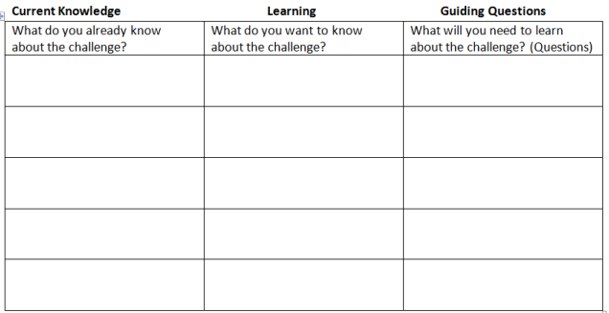

**GUIDED QUESTION 1:**

**GUIDED QUESTION 2:**

**GUIDED QUESTION 3:**

**ETC.**

**TESTING FILTER MATERIALS**

**In lab notebook:**

* **Which variable will you test for your experiment?**
* **What variables do you have to keep the same (constant) as you perform this experiment?**
* **Perform Test using Engineering Design Process**
  + **Identify the Problem**
  + **Identify Criteria & Constraints**
  + **Brainstorm Solutions**
  + **Generate Idea/Explore Possibilities**
  + **Select Approach**
  + **Build a Prototype**
  + **Revise & Refine**

**COLLECT RESULTS FROM CLASSMATES:**

For each, record results after both the first and second filtration of 300 ml of water

For these tests, students can write “removed all,” “removed some,” or “removed none” in the first four test columns. They will use pH strips to measure the pH of water and will time how long it takes to filter 200 mL of water. As groups present, students add a new row to the table, write the order of filter materials used and the groups’ results.

|  |  |  |  |  |  |  |
| --- | --- | --- | --- | --- | --- | --- |
| **Layers in Filter** | **How many visible particles did filter remove?** | **Did filter remove color from water?** | **Did filter remove odor from water?** | **Did filter remove oil from water?** | **pH of water** | **How long did it take to filter 300 ml?** |
| **CONTROL (unfiltered water)** | **/** | **/** | **/** | **/** | **/** | **/** |
| **Filter 1, filter 2, filter 3** | **/** | **/** | **/** | **/** | **/** | **/** |
| **Filter 1, filter 2, filter 3** | **/** | **/** | **/** | **/** | **/** | **/** |

**THE BIG CHALLENGE: Design a Water Filtering Kit**

* **Perform Test using Engineering Design Process**
  + **Identify the Problem**
  + **Identify Criteria & Constraints**
  + **Brainstorm Solutions**
  + **Generate Idea/Explore Possibilities**
  + **Select Approach**
  + **Build a Prototype**
  + **Revise & Refine**

(The blank columns will be determined by the water quality test strips purchased.)

|  |  |  |  |  |  |  |  |  |  |  |
| --- | --- | --- | --- | --- | --- | --- | --- | --- | --- | --- |
| Test | Color (removed all, some or none) | Smell (removed all, some or none) | Turbidity (removed all, some or none) | pH | Volume of water filtered in 5 min | Chlorine  (0-10 mg/L) | Nitrates  (mg/L) | Nitrates (mg/L) | Total hardness (mg/L) | #of Bacterial colonies grown |
| Before  Filtering |  |  |  |  |  |  |  |  |  |  |
| After  Filtering |  |  |  |  |  |  |  |  |  |  |
| After Redesign |  |  |  |  |  |  |  |  |  |  |

|  |  |  |
| --- | --- | --- |
| **Name: Elizabeth Carlson** | **Contact Info:** [**ecarlson@hcsdoh.org**](mailto:ecarlson@hcsdoh.org) | **Date: 7/11/14** |

|  |  |  |  |
| --- | --- | --- | --- |
| **Lesson Title : Lesson 1: Safe Drinking Water** | **Unit #:**  **1** | **Lesson #:**  **1** | **Activity #:**  **2** |
| **Activity Title: Activity 2: Properties of Water** |

|  |  |
| --- | --- |
| **Estimated Lesson Duration:** | **1 week** |
| **Estimated Activity Duration:** | **4 days** |

|  |  |
| --- | --- |
| **Setting:** | **HHS, Room 204** |

|  |
| --- |
| **Activity Objectives:** |

* Identify and explain the properties of water (polarity, adhesion/cohesion, density, solutions, pH)
* Explain how each property of water is important for sustaining life.

|  |
| --- |
| **Activity Guiding Questions:** |

* What could be in the water making it unsafe to drink?
* Are there living or non-living things in contaminated water?
* Why do we need water?
* How does the structure of water affect its ability to dissolve a wide variety of solutes?
* How does the structure of water affect its ability to “stick” to itself and other materials?
* How does the structure of water affect the Earth’s climate?
* How do different materials change water’s pH?

| **Next Generation Science Standards (NGSS)** | |
| --- | --- |
| **Science and Engineering Practices (Check all that apply)** | **Crosscutting Concepts (Check all that apply)** |
| ☐ Asking questions (for science) and defining problems (for engineering) | ☐ Patterns |
| ☐ Developing and using models | ☒ Cause and effect |
| ☐ Planning and carrying out investigations | ☐ Scale, proportion, and quantity |
| ☐ Analyzing and interpreting data | ☐ Systems and system models |
| ☐ Using mathematics and computational thinking | ☐ Energy and matter: Flows, cycles, and conservation |
| ☐ Constructing explanations (for science) and designing solutions (for engineering) | ☒ Structure and function. |
| ☐ Engaging in argument from evidence | ☒ Stability and change. |
| ☐ Obtaining, evaluating, and communicating information |  |

| **Ohio’s New Learning Standards for Science (ONLS)** |
| --- |
| **Expectations for Learning - Cognitive Demands (Check all that apply)** |
| ☐ Designing Technological/Engineering Solutions Using Science concepts **(T)** |
| ☒ Demonstrating Science Knowledge **(D)** |
| ☒ Interpreting and Communicating Science Concepts **(C)** |
| ☒ Recalling Accurate Science **(R)** |

| **Common Core State Standards -- Mathematics (CCSS)** | |
| --- | --- |
| **Standards for Mathematical Practice (Check all that apply)** | |
| ☐ Make sense of problems and persevere in solving them | ☐ Useappropriate tools strategically |
| ☐ Reason abstractly and quantitatively | ☐ Attendto precision |
| ☐ Construct viable arguments and critique the reasoning of others | ☐ Look for and make use of structure |
| ☐ Model with mathematics | ☐ Look for and express regularity in repeated reasoning |

|  |
| --- |
| **Unit Academic Standards (NGSS, ONLS and/or CCSS):** |

Within the cell are specialized parts for the transport of materials, energy transformation, protein building, waste disposal, information feedback and movement

The essential functions of cells involve chemical reactions that involve water and carbohydrates, proteins, lipids and nucleic acids. A special group of proteins, enzymes, enables chemical reactions to occur within living systems.

Most cells function within a narrow range of temperature and pH. At very low temperatures, reaction rates are slow.

Role of water and organic molecules in cells (lipids, carbohydrates, nucleic acids, proteins);

|  |
| --- |
| **Materials**: (Link Handouts, Power Points, Resources, Websites, Supplies) |

White copy paper/staples

Pennies

Droppers/pipets

Vegetable oil

Isopropyl (rubbing) alcohol

Salt

Sugar

Wax paper

Toothpicks

Thermometers

Flasks/beakers

Hotplate

Ice

Common acids/bases

Red cabbage juice

|  |
| --- |
| **Teacher Advance Preparation:** |

Boil red cabbage and save the water for pH indicator

|  |
| --- |
| **Activity Procedures:** |

* Students will make a water book out of four sheets of copy paper. Cover: Properties of Water
* Six Properties: One per each pair of pages. (Water is a polar molecule, Water is Sticky, Water is a Universal Solvent, The States of Water, Water has a high specific heat & heat of vaporization, Water can be separated into ions)
* For “Water is a Polar Molecule,” students draw and label a water molecule, describe the arrangement of electrons in the molecule (shared between an oxygen and hydrogen atom, but closer to oxygen, because it is more electronegative), draw a picture showing hydrogen bonds between several water molecules
* For properties 2-6, structure pages like

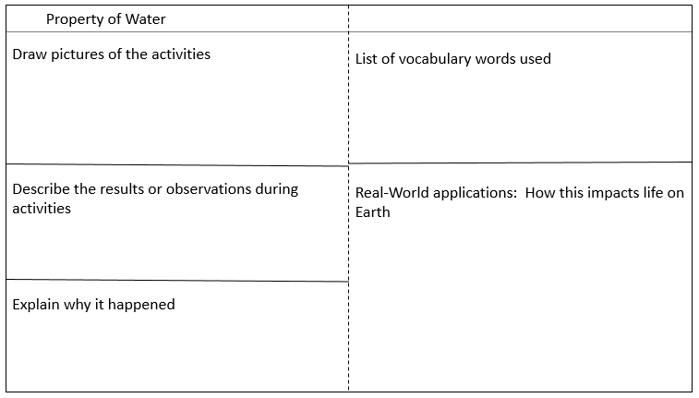

* Activities: I will guide the activities to control pacing and check for understanding. After the groups perform a hands-on activity/watch a demo, each student will draw their pictures in the water book (in pencil), describe what they saw and write a possible explanation for how the structure of water caused the results (in pencil or blue/black ink). They can discuss their explanations within their groups, but have to write on their own. Afterwards, I will ask group reporters to give their explanations. If the students are on track, we’ll move on. If there are misconceptions, I will provide clarification. Students will make corrections to their explanations using their “flair,” or colored pen. Students receive full credit for their corrections in flair, as long as they have a reasonable attempt at an explanation written in pencil/boring pen.
  + Water is sticky: Groups of 2
    - # of drops on a penny, water race—water drop dragged by toothpick on wax paper, floating pepper/disrupt with soap, water rising up paper towel
    - Vocabulary: adhesion, cohesion, capillary action, surface tension
  + Water is a Universal Solvent: Groups of 4
    - Attempt to dissolve salt, sugar and oil in water, rubbing alcohol and vegetable oil. Afterwards, demonstrate layering with salt water and tap water to show density difference in high concentration solution.
    - Vocabulary: solute, solvent, solution, concentration, polar, nonpolar, hydrophilic, hydrophobic
  + The States of Water: Whole class demonstration
    - Have 2 beakers containing clear liquids (water and rubbing alcohol) and drop ice cubes into each.
    - Vocabulary: solid, liquid, gas, density, water cycle
  + Water has a high specific heat & heat of vaporization: Whole class demonstration
    - On hot plate, take temperature of equal amounts of water, rubbing alcohol and vegetable oil, every two minutes until after boiling. As water is boiling, point out all three states of matter on same table.
    - Vocabulary
  + Water can be separated into ions: Groups of 2
    - Fill reaction wells with cabbage juice. Mix different household acids/bases to see color change and compare to pH chart. (Use vinegar, lemon juice, sprite, dish soap, ammonia, etc.)
    - Vocabulary: acid, base, pH, hydroxide ion, hydronium ion

Homework: Use textbook, video resources, PowerPoint to determine how each property impacts life on Earth.

**Formative Assessments:** Link the items in the Activities that will be used as formative assessments.

Traffic cards—red/yellow/green cards

Students will have their cards out on the corner of their desks. If they understand what they see and why it happens, they keep the green showing. If they get a little confused, they change to yellow. If they are very confused, they can put the red up.

As I supervise the activities or explain the concepts, I monitor the colors. If kids forget to change the cards, I’ll do periodic “card flashes”—when the I ask the kids to actually hold up their appropriate card.

**Summative Assessments:** These are optional; there may be summative assessments at the end of a set of Activities or only at the end of the entire Unit.

Water book

|  |
| --- |
| **Differentiation:** Describe how you modified parts of the Lesson to support the needs of different learners.  Refer to Activity Template for details. |

|  |
| --- |
| **Reflection:** Reflect upon the successes and shortcomings of the lesson. |

|  |  |  |
| --- | --- | --- |
| **Name: Elizabeth Carlson** | **Contact Info: ecarlson@hcsdoh.org** | **Date: 7/11/14** |

|  |  |  |  |
| --- | --- | --- | --- |
| **Lesson Title : Lesson 2: Filtering Water** | **Unit #:**  **1** | **Lesson #:**  **2** | **Activity #:**  **3** |
| **Activity Title: Activity 1: Testing Filter Materials** |

|  |  |
| --- | --- |
| **Estimated Lesson Duration:** | **2 weeks** |
| **Estimated Activity Duration:** | **3-5 days** |

|  |  |
| --- | --- |
| **Setting:** | **HHS, Room 204** |

|  |
| --- |
| **Activity Objectives:** |

* Use the engineering design process to design and execute a test of water filtering materials
* Communicate results of experiments to the rest of the class
* Use filters to remove the color, odor, oil from water and return the pH to 7-8

|  |
| --- |
| **Activity Guiding Questions:** |

* What methods can be used to remove visible particles from water?
* Does removing just the visible (big) particles make water “clean?”

| **Next Generation Science Standards (NGSS)** | |
| --- | --- |
| **Science and Engineering Practices (Check all that apply)** | **Crosscutting Concepts (Check all that apply)** |
| ☒ Asking questions (for science) and defining problems (for engineering) | ☐ Patterns |
| ☐ Developing and using models | ☐ Cause and effect |
| ☒ Planning and carrying out investigations | ☐ Scale, proportion, and quantity |
| ☐ Analyzing and interpreting data | ☐ Systems and system models |
| ☐ Using mathematics and computational thinking | ☐ Energy and matter: Flows, cycles, and conservation |
| ☐ Constructing explanations (for science) and designing solutions (for engineering) | ☐ Structure and function. |
| ☐ Engaging in argument from evidence | ☐ Stability and change. |
| ☐ Obtaining, evaluating, and communicating information |  |

| **Ohio’s New Learning Standards for Science (ONLS)** |
| --- |
| **Expectations for Learning - Cognitive Demands (Check all that apply)** |
| ☒ Designing Technological/Engineering Solutions Using Science concepts **(T)** |
| ☐ Demonstrating Science Knowledge **(D)** |
| ☒ Interpreting and Communicating Science Concepts **(C)** |
| ☐ Recalling Accurate Science **(R)** |

| **Common Core State Standards -- Mathematics (CCSS)** | |
| --- | --- |
| **Standards for Mathematical Practice (Check all that apply)** | |
| ☐ Make sense of problems and persevere in solving them | ☐ Useappropriate tools strategically |
| ☐ Reason abstractly and quantitatively | ☐ Attendto precision |
| ☒ Construct viable arguments and critique the reasoning of others | ☐ Look for and make use of structure |
| ☐ Model with mathematics | ☐ Look for and express regularity in repeated reasoning |

|  |
| --- |
| **Unit Academic Standards (NGSS, ONLS and/or CCSS):** |

Most cells function within a narrow range of temperature and pH. At very low temperatures, reaction rates are slow.

Role of water and organic molecules in cells (lipids, carbohydrates, nucleic acids, proteins)

|  |
| --- |
| **Materials**: (Link Handouts, Power Points, Resources, Websites, Supplies) |

File: Engineering Notebook Guide—Water Filtering

File: Testing procedure worksheet: Water Filtering Procedures

Supplies:

Panty hose

Rubber bands

pH test strips

rulers

cups

graduated cylinder

aquarium gravel

sand

activated charcoal

marbles

cotton balls

coffee filters

Styrofoam “popcorn”

20 oz soda bottle

|  |
| --- |
| **Teacher Advance Preparation:** |

Prepare “Grey water” using brewed tea, vinegar (pH around 4), vegetable oil and potting soil.

|  |
| --- |
| **Activity Procedures:** |

Students will work in their teams of 3-4.

Testing procedures are similar to an activity called “Cleaning Water” from nasa.gov (attached as a reference).

Testing procedure worksheet: Water Filtering Procedures

Have the students continue working in the Engineering Notebook file called “Water Filtration Challenge,” starting in the section called “TESTING FILTER MATERIALS**.”** They will fill that in using the format modeled in “Engineering Notebook Guide—Water Filtering.”

After finishing the presentations from Activity #2, introduce the challenge.

“Now that we’ve identified the problem (providing safe drinking water), and have learned about water and the ways it can be contaminated, it’s time to develop a way to clean contaminated water. Before you can design your own water filtering kit, you need to know more about materials that could be used in your filter. In your groups, brainstorm different uses for filters in your home.” Give 3-5 minutes before teams share and a list is compiled on the board. “Now, come up with a list of materials that are used in those filters.” Give 3-5 minutes before teams share and come up with a class list of filtering materials that can be found around the house. “Tomorrow, you will layer three filtering materials in a soda bottle and run contaminated water through to determine the effectiveness of that combination of materials at cleaning water. You will draw for your first two materials, but will also need to brainstorm what third material, one that I’m not providing, that you’d like to bring from home to add to your test.”

Put slips of paper into a hat/bowl and have groups draw two slips of paper each. You can have a set of pre-made slips, but writing them as, or right after, the class list is created will be more effective for student buy-in. Put checks next to the items students listed that will be provided for them. Other items on the list can be brought in as the student’s third filtering material.

Students will work through and complete the engineering design process. They document their progress in their engineering notebooks.

* **Which variable will you test for your experiment?**
* **What variables do you have to keep the same (constant) as you perform this experiment?**
* **Perform Test using Engineering Design Process**
  + **Identify the Problem**
  + **Identify Criteria & Constraints**
  + **Brainstorm Solutions**
  + **Generate Idea/Explore Possibilities**
  + **Select Approach**
  + **Build a Prototype**
  + **Revise & Refine**

**As students work together, each student will keep records of individual and group progress by taking notes, inserting photographs or sketches in the team’s engineering notebook.**

After completing their tests, students will present their filter combinations and results from filtering the “grey water.”

reference)

**Formative Assessments:** Link the items in the Activities that will be used as formative assessments.

progress checks in engineering notebooks

**Summative Assessments:** These are optional; there may be summative assessments at the end of a set of Activities or only at the end of the entire Unit.

group presentation of results

|  |
| --- |
| **Differentiation:** Describe how you modified parts of the Lesson to support the needs of different learners.  Refer to Activity Template for details. |

|  |
| --- |
| **Reflection:** Reflect upon the successes and shortcomings of the lesson. |

**Procedure: Filter Material Testing**

**Pre-lesson Instructions**

* Students should work in groups of 3 or 4.
* Write the names of the 7 different filtering materials on 7 individual small slips of paper and place them in a hat or basket. Each group also will bring in a “free choice” material from home to test.
* Gather materials for this activity. Each filtration material needs to fill the water filtering system to a depth of 3-6 cm. There should be enough of each filtration material for several groups to use. Make sure to have extra material for students to choose their “free choice” options.
* Wad-up enough coffee filters for multiple groups to use as a filtration layer.
* Rinse the activated charcoal granules in advance to remove the dust.
  + Put the granules in a mesh bag (panty hoses work well) and rinse with tap water.
* Construct the water filtering system structure: (one per group)
  + Punch a hole in the top of each cup, just below the rim to avoid a vacuum.
  + Remove the labels on the 20 oz. bottles and then cut off the bottom of the bottle, just above the curve of the bottle.
  + Construct the structure of the water filtering system by covering the mouth of the bottle with a layer of panty hose or cheesecloth and secure with a rubber band.

See diagram:

**Testing Procedures:**

1. Put on your safety glasses. *Stress the importance of keeping eye protection on during this lesson.*
2. Place the bottle upside down with its mouth over the clear plastic cup to catch the filtered water. (See diagram of the Cleaning Water Filtering System.) *Make sure the cup underneath the system is large enough to “catch” the water to be filtered through.*
3. Choose two slips of paper from the teacher. The items written on these papers will be the materials you layer in your water filter. You will also include a “free choice,” so you and your group may choose what material to use for this filtration layer.
4. Gather your filtration materials on the paper plates; one on each plate. As a group, decide the order in which to layer your materials.
5. Fill the bottle with the first filtering material to a depth of 3-6 centimeters (cm). Note: Coffee filters and cotton balls will need to be packed down.
6. Place the second filtering material to a depth of 3-6 cm on top of the first one.
7. Place the third filtering material to a depth of 3-6 cm on top of the second filtering material.
8. Obtain 300 ml of clean water. Observe the properties of the water before you filter it. Use the wafting technique to smell the water. Measure the pH of the water with litmus paper and compare it to the pH color chart. ***Collect data*** and ***record*** your observations on the Cleaning Water Data Sheet. Remember smelling rules in the science lab and do not taste. *This pH measurement will serve as the control. When filtering the gray water, students will know the gray water is cleaned when it matches the control pH.*
9. Run the clean water through your water filtering system to make sure it will allow water to flow through. *Students should run approximately 10-16 oz. of clean water through their water filtering system to make sure it will allow water to flow through. Make sure the cup underneath the system is large enough to “catch” all the water passing through.*
10. While you are waiting for the clean water to run through the water filtering system, draw and label your diagram to match your filtration system. *Have each student sketch in the filtration materials and label each layer on the diagram in the Cleaning Water Student Section.*

**-- SUGGESTED PLACE TO STOP ACTIVITY. RESUME AT NEXT CLASS PERIOD. –**

*If you stop the activity here, the filtering materials may dry-out before you resume. The filtration system will need to be “wet” again with another 500 ml. of clean water when you are ready to resume the activity.*

1. Once the clean water has gone through the water filtering system, replace the clear plastic cup with a new one. If the water is sandy, it should be disposed of outside. Otherwise, it can be disposed of in the sink. *The cup can be reused in the next step.*
2. Get 300 ml of gray water. Observe the properties of the water before you filter it. Check the odor of the water. Measure the pH of the water with litmus paper and compare it to the pH color chart. ***Collect data*** and ***record*** your observations on the Cleaning Water Data Sheet. *Remind students to use the wafting technique to smell the water. They should also measure the pH of this water sample. Go over the rules of the science lab regarding smelling and tasting.*
3. Run the gray water through your water filtering system. Observe the properties of the water after it has been filtered once and record your observations on the Data Sheet. Measure the pH of the water with litmus paper and compare it to the pH color chart. ***Collect data*** and ***record*** your observations on the Cleaning Water Data Sheet. *Remind students the rules of the science lab regarding smelling and tasting.*
4. Replace the clear plastic cup with a new one. Pour the filtered water back into the water filtering system.
5. Filter the water again. While the gray water is running through the water filtering system, discuss in your group what each layer in your filtration system did to the water.
6. Observe the properties of the water after it has been filtered for the second time. Check the odor of the water. Measure the pH of the water with litmus paper and compare it to the pH color chart. ***Collect data*** and ***record*** your observations on the Cleaning Water Data Sheet. *Remind students the rules of the science lab regarding smelling and tasting.*

|  |  |  |
| --- | --- | --- |
| **Name: Elizabeth Carlson** | **Contact Info:** [**ecarlson@hcsdoh.org**](mailto:ecarlson@hcsdoh.org) | **Date: 7/21/14** |

|  |  |  |  |
| --- | --- | --- | --- |
| **Lesson Title : Filtering Water** | **Unit #:** | **Lesson #:** | **Activity #:** |
| **Activity Title: Designing a Water Filter Device** |

|  |  |
| --- | --- |
| **Estimated Lesson Duration:** | **2 weeks** |
| **Estimated Activity Duration:** | **5-7 days** |

|  |  |
| --- | --- |
| **Setting:** | **HHS, Room 204** |

|  |
| --- |
| **Activity Objectives:** |

* Use the engineering design process to design and execute a test of a water filtering device
* Communicate results of experiments to the rest of the class
* Use filters to remove the color, odor, and particles from contaminated and return the pH to 7-8

|  |
| --- |
| **Activity Guiding Questions:** |

* What could be in the water making it unsafe to drink?
* Are there living or non-living things in contaminated water?
* What methods can be used to remove visible particles from water?
* Does removing just the visible (big) particles make water “clean?”
* Why do we need water?
* How much water does a person need each day?
* What living/nonliving things can be in contaminated water and make people sick?
* What causes water to become contaminated?
* What diseases can people get from drinking contaminated water?

| **Next Generation Science Standards (NGSS)** | |
| --- | --- |
| **Science and Engineering Practices (Check all that apply)** | **Crosscutting Concepts (Check all that apply)** |
| ☒ Asking questions (for science) and defining problems (for engineering) | ☐ Patterns |
| ☒ Developing and using models | ☐ Cause and effect |
| ☒ Planning and carrying out investigations | ☐ Scale, proportion, and quantity |
| ☒ Analyzing and interpreting data | ☐ Systems and system models |
| ☐ Using mathematics and computational thinking | ☐ Energy and matter: Flows, cycles, and conservation |
| ☒ Constructing explanations (for science) and designing solutions (for engineering) | ☒ Structure and function. |
| ☐ Engaging in argument from evidence | ☐ Stability and change. |
| ☒ Obtaining, evaluating, and communicating information |  |

| **Ohio’s New Learning Standards for Science (ONLS)** |
| --- |
| **Expectations for Learning - Cognitive Demands (Check all that apply)** |
| ☒ Designing Technological/Engineering Solutions Using Science concepts **(T)** |
| ☒ Demonstrating Science Knowledge **(D)** |
| ☒ Interpreting and Communicating Science Concepts **(C)** |
| ☐ Recalling Accurate Science **(R)** |

| **Common Core State Standards -- Mathematics (CCSS)** | |
| --- | --- |
| **Standards for Mathematical Practice (Check all that apply)** | |
| ☒ Make sense of problems and persevere in solving them | ☐ Useappropriate tools strategically |
| ☐ Reason abstractly and quantitatively | ☐ Attendto precision |
| ☐ Construct viable arguments and critique the reasoning of others | ☐ Look for and make use of structure |
| ☐ Model with mathematics | ☐ Look for and express regularity in repeated reasoning |

|  |
| --- |
| **Unit Academic Standards (NGSS, ONLS and/or CCSS):** |

Most cells function within a narrow range of temperature and pH. At very low temperatures, reaction rates are slow.

Role of water and organic molecules in cells (lipids, carbohydrates, nucleic acids, proteins

|  |
| --- |
| **Materials**: (Link Handouts, Power Points, Resources, Websites, Supplies) |

File: Engineering Notebook Guide—Water Filtering

Supplies:

Panty hose

Rubber bands

pH test strips

rulers

cups

graduated cylinder

aquarium gravel

sand

activated charcoal

marbles

cotton balls

coffee filters

Styrofoam “popcorn”

20 oz soda bottles

Water Test strips

Water from local river, lake, or pond (ours will be from the Great Miami River at the low level dam in Hamilton, OH)

**Optional—I will add a culture of harmless bacteria that produce red protein so colony growth is clear and easy to see

|  |
| --- |
| **Teacher Advance Preparation:** |

Produce more “grey water” for use in initial tests, if supply is low from activity #3

Collect water from a local water source (river, lake, creek, or pond)

|  |
| --- |
| **Activity Procedures:** |

The challenge: Each group of students will design and build a water filtration kit that can be stored, jostled, quickly prepared and used to clean contaminated drinking water of both visible and invisible particles, including both biotic and abiotic materials. The filter should remove color, odor and particles from the water and change the pH to range between 7-8. 500 mL of river water should be cleaned in 5 minutes.

Continue work in our Engineering Notebook Google document. As students work through each step, they record their ideas, sketches and questions in their notebooks.

* **Perform Test using Engineering Design Process**
  + **Identify the Problem**
  + **Identify Criteria & Constraints**
  + **Brainstorm Solutions**
  + **Generate Idea/Explore Possibilities**
  + **Select Approach**
  + **Build a Prototype**
  + **Revise & Refine**

To perform the challenge, students repeat the engineering process, focusing now on the final product: the water filtration kit. Students can either use their cleaned 20 oz bottle or bring a different container to use from home.

The following are the steps we will work through to perform the challenge. I will guide the students through the first three steps, making sure the groups take the time to brainstorm and sketch out a variety of ideas, from which they will develop their prototype. (Otherwise, students will probably skip to the building stage of the process.) Groups have to have each step approved by me before moving to the next step.

* ID problem, ID criteria & constraints, brainstorm as individuals—everyone must sketch out 2 different ideas, using data collected from all of the groups from all of the classes to help.
* Compare/combine ideas, use those to decide on an approach to take to solve the problem.
* Sketch out design with measurements/amounts
* Build prototype
* Test prototype with grey water
* Revise prototype
* Test with river water—test chemicals, bacterial cultures
* Review results—Reexamine design. Suggest & Implement improvements
* Retest.

**Formative Assessments:** Link the items in the Activities that will be used as formative assessments.

* Spot checks—students on task
* Traffic cards on desk (Green = fine, Yellow = a bit confused, Red = Lost/HELP!)

**Summative Assessments:** These are optional; there may be summative assessments at the end of a set of Activities or only at the end of the entire Unit.

Engineering notebook

Filter’s ability to clean water—chart/rubric is found in the Engineering Notebook Guide-Water Filtering handout

|  |
| --- |
| **Differentiation:** Describe how you modified parts of the Lesson to support the needs of different learners.  Refer to Activity Template for details. |

Students work in heterogeneous teams

|  |
| --- |
| **Reflection:** Reflect upon the successes and shortcomings of the lesson. |

**14. APPENDIX III: UNIT TEMPLATE OF TEACHER # 2**

|  |  |  |
| --- | --- | --- |
| **Name: Eryn Ruder** | **Contact Info:** [**nwbioteach@gmail.com**](mailto:nwbioteach@gmail.com) | **Date: 7/28/2014** |

|  |
| --- |
| **Unit Number and Title: Are Students Sick of School or Is School Making Students Sick?** |

|  |  |
| --- | --- |
| **Grade Level: 10-12** |  |

|  |  |
| --- | --- |
| **Subject Area:** | Biology |

|  |  |
| --- | --- |
| **Total Estimated Duration of Entire Unit:** | 3 weeks |

|  |
| --- |
| **Unit Summary** |

The Big Idea (including global relevance):

Life is complicated. Students will investigate the biology of school attendance in regards to the

following question: Are students sick of school or does school make students sick?

Improving school attendance by identifying variables that cause students to miss school. Attendance is a non-academic measure that schools are evaluated on by the state of Ohio. Students will examine data relating to number of school days missed and the reasons given and the number of students awarded perfect attendance. Students can analyze the data to determine the top causes for missed days.

The Essential Question:

How can we improve school attendance by preventing the spread of illness among students?

|  |
| --- |
| **Unit Context** |

Justification for Selection of Content:

Data from midterm and final exams indicate that students often struggle with the retention of knowledge regarding the concepts associated with the characteristics of living things including: biotic vs. abiotic factors, and homeostasis, especially the importance of water. In order to grasp more complex concepts in biology and upper level life science courses students must be able to evaluate a specimen and determine if it is biotic or abiotic and they must understand the properties of water and the role water plays in cellular processes including the maintenance of homeostasis. Integrating these topics into a Challenged Based Learning with Engineering Design Process lesson will make these topics applicable and relevant to my students while they solve a real world problem that directly impacts their lives.

The Challenge:

Design a comprehensive method or procedure and/or structural changes to the physical environment and campaign for a method for reducing the spread of bacteria and viruses on school grounds.

Teams must design a multiple approach method that includes the following:

1. Personal hygiene

2. School facilities (physical environment and procedures)

3. Elicit participation by school community

The Hook:

* Students will be given petri dishes and sterile swabs to incubate cultures gathered on school grounds. Teams will each choose 4 locations, 2 predicted to not harbor bacteria and 2 predicted to have bacteria. Students will observe the dishes over a 1 week period.
* News reel footage of norovirus outbreak on a Cruise Ship
* News story of norovirus outbreak at a school, <http://krqe.com/2014/05/01/school-closes-due-to-suspected-norovirus-outbreak/>
* Nathan Wolfe Virus Hunter Video, //www.ted.com/talks/nathan_wolfe_hunts_for_the_next_aids
* New attendance requirements from the state of Ohio.
* Dehydrated Arizona teen dies during Mexico vacation after drinking Red Bull news story

Teacher’s Guiding Questions:

What are the common causes of illness?

How does illness spread?

What causes diarrhea and vomiting?

What can we do to treat diarrhea and vomiting?

Why is dehydration a danger?

Why is water important to life?

How big are viruses and bacteria?

What does it mean to be alive?

Are viruses and bacteria alive?

How can we “kill” viruses and bacteria?

What is the difference between human cells and bacterial cells and viruses?

ACS (Real world applications; career connections; societal impact):

Applications: The benefits of implementing the students’ designs will result in the district meeting the State of Ohio attendance requirements by the reduction of illness among student population. The individual students will benefit from improved personal hygiene habits. The school community will benefit from increased public awareness of disease transmission.

Career Connections:

* Engineering (Environmental, Genetic)
* Public Health Official
* Scientist/Researcher
* Microbiologist
* Medical Careers
* Public Relations

Societal Impact: Society will benefit from a population that practices improved personal hygiene which will result in improved public health. An increase in school attendance will result in improved academic performance and increase student achievement.

Engineering Design Process (EDP):

1. Identify the problem: After teacher introduces the problem students will identify the problem as how to reduce the spread of bacteria and viruses on school grounds.
2. Identify criteria and constraints: The solution must involve personal cleanliness, school facilities/procedures, and eliciting participation by the school community.
3. Brainstorm possible solutions: Student teams will provide ideas about how they can reduce the spread of illness on school grounds after the introduction of the Big Idea.
4. Generate ideas: Student teams will generate ideas after the introduction of the Challenge and after the following explorations: the properties of water through mini-labs, the characteristics of life and comparison of eukaryotes, prokaryotes, and viruses (in regards to energy use, reproduction/heredity, and homeostasis), student body personal hygiene habits (survey), and the school grounds for aspects of the physical environment or procedures that promote the spread of bacteria and viruses.
5. Explore possibilities: Students will examine hand washing techniques using GloGerm to test the effectiveness of their approach. Students will suggest changes to the school environment or procedures (not expensive nor time consuming) that can be made to reduce the spread of illness. Students will suggest methods for communicating the solutions to the appropriate audience.
6. Select approach: Student teams will each select one personal hygiene habit, one suggested change to a physical feature or procedure on school grounds, and a method for communicating solutions and eliciting participation by the school community.
7. Build model, prototype, or design process: Students will create a plan to reduce the spread of illness on school grounds that includes personal hygiene, improved facilities/procedures, and community awareness and buy in. Students will gather data about student personal hygiene habits via a quarterly survey to measure participation. Students will examine quarterly attendance data and compare it to past school years to determine the effect of the plan.
8. Communicate ideas: Student teams will communicate research finding and test results throughout the process. Teams will communicate their plans for improving school attendance by reducing the spread of illness to the school community. Teams will communicate the suggested changes to school facilities/procedures to the appropriate administrators.
9. Refine the process: Student teams will refine personal hygiene techniques after sharing hand washing findings with other teams. Teams will refine suggested changes to school facilities/procedures after meeting with building administrators and custodial staff. Student teams will refine the personal cleanliness and communication portions to be used by the feeder elementary school.

| **Next Generation Science Standards (NGSS)** | |
| --- | --- |
| **Science and Engineering Practices (Check all that apply)** | **Crosscutting Concepts (Check all that apply)** |
| ☒ Asking questions (for science) and defining problems (for engineering) | ☐ Patterns |
| ☐ Developing and using models | ☒ Cause and effect |
| ☒ Planning and carrying out investigations | ☐ Scale, proportion, and quantity |
| ☒ Analyzing and interpreting data | ☐ Systems and system models |
| ☒ Using mathematics and computational thinking | ☐ Energy and matter: Flows, cycles, and conservation |
| ☒ Constructing explanations (for science) and designing solutions (for engineering) | ☒ Structure and function. |
| ☐ Engaging in argument from evidence | ☒ Stability and change. |
| ☒ Obtaining, evaluating, and communicating information |  |

| **Ohio’s New Learning Standards for Science (ONLS)** |
| --- |
| **Expectations for Learning - Cognitive Demands (Check all that apply)** |
| ☒ Designing Technological/Engineering Solutions Using Science concepts **(T)** |
| ☒ Demonstrating Science Knowledge **(D)** |
| ☐ Interpreting and Communicating Science Concepts **(C)** |
| ☐ Recalling Accurate Science **(R)** |

| **Common Core State Standards -- Mathematics (CCSS)** | |
| --- | --- |
| **Standards for Mathematical Practice (Check all that apply)** | |
| ☐ Make sense of problems and persevere in solving them | ☐ Useappropriate tools strategically |
| ☒ Reason abstractly and quantitatively | ☐ Attendto precision |
| ☒ Construct viable arguments and critique the reasoning of others | ☐ Look for and make use of structure |
| ☐ Model with mathematics | ☐ Look for and express regularity in repeated reasoning |

|  |
| --- |
| **Unit Academic Standards (NGSS, ONLS and/or CCSS):** |

Cells:

* Eukaryotic cells and prokaryotic cells
* Characteristics of life regulated by cellular processes
* The essential functions of cells involve chemical reactions that involve water and carbohydrates, proteins, lipids and nucleic acids

|  |
| --- |
| **Unit Lessons and Activities:** (Link here.) |

Lesson 1: Importance of water to life.

Lesson 1 will focus on the properties of water and the importance of the molecule to all living things. Students will have the opportunity to explore the properties of water and determine the best technique for hand washing.

Activity 1. Introduction of the Big Idea, Generating the Essential Question, Challenge and Guiding

Questions.

Activity 2. Investigating the properties of water to build a better hand washing technique.

Lesson 2. How do you kill something that isn’t alive?

Lesson 2 enables students to investigate the characteristics of life by comparing the reproduction/heredity, energy use, and maintenance of homeostasis by eukaryotes, prokaryotes, and viruses. They will be surveying school facilities and procedures to determine what can be changed to deter the spread of bacteria and viruses among the student population.

Activity 3. What is life?

Activity 4. Design a change to school facility or procedure to reduce the spread of bacteria and viruses

among student population.

|  |
| --- |
| **Where the CBL and EDP appear in the Unit: (Please provide the Lesson #’s and Activity #’s)** |

Lesson 1 Activity 1 and Activity 2, and Lesson 2 Activity 2 has Challenge Based Learning and Engineering Design Process embedded. Lesson 1 Activity 1 includes the generation of the Essential question and the introduction of the Challenge. Lesson 1 Activity 2 involves the design of a hand washing technique (EDP). Lesson 2 Activity 2 requires the redesign of a school facility or procedure. The iterative process of EDP appears here.

|  |
| --- |
| **Background Knowledge:** |

Students need to know or have the following skills:

1. Steps of the engineering design process
2. Scientific method
3. Abiotic vs. biotic
4. Major causes of illness
5. Molecular structure of water
6. Polar properties of water molecules (hydrogen bonding)
7. Cell theory
8. Power Point presentation creation
9. Basic mathematical calculations

|  |
| --- |
| **Misconceptions:** |

* All cells have a nucleus
* All organisms reproduce sexually
* 5 second rule
* All living things breathe
* Viruses are alive
* Homeostasis is a type of mixture
* Plants aren’t alive

|  |
| --- |
| **Additional Resources:** |

|  |
| --- |
| **Pre-Unit Assessment Instrument: (Link it here.)** |

10 question multiple choice and matching.

|  |
| --- |
| **Post-Unit Assessment Instrument: (Link it here.)** |

10 question multiple choice and matching

|  |
| --- |
| **Results: Evidence of Growth in Student Learning - A**fter teaching the Unit, present the evidence below that growth in learning was measured through one of the instruments identified above. Show results of assessment data that prove growth in learning occurred.  **Please hyperlink**:   * Any documents used to collect and organize post unit evaluation data. (charts, graphs and /or tables etc.) * An analysis of data used to measure growth in student learning providing evidence that student learning occurred. (Sentence or paragraph form.) |

|  |
| --- |
| **How to Make This a Hierarchical Unit: (Check one of the following.)**      ☐ Middle School Unit ☒ High School Unit  **Refer to the Unit Template Description. Complete A or B below, whichever is applicable.** |

Grade 6 Life Science: Cellular to Multicellular

This topic focuses on the study of the basics of Modern Cell Theory. All organisms are composed of cells, which are the fundamental unit of life. Cells carry on the many processes that sustain life. All cells come from pre-existing cells.

Modify Lesson 2 Activity 2 to limit the research to eukaryotes and prokaryotes (eliminate viruses). Add the requirement that students indicate which organelle is responsible for: energy, heredity, and homeostasis.

Modify the challenge to address the effect of different solution concentrations on cells. Predict what will happen when a cell is placed in solutions of varying concentration levels. Then plan and conduct a scientific investigation to prove or disprove predictions. The results can be applied when challenged to develop an improved hand washing technique that will kill bacteria (prokaryotes) but not the cells of the skin (eukaryote).

|  |
| --- |
| **Poster:** Link document. |

|  |
| --- |
| **Video:** Link Video. |

|  |
| --- |
| **Reflection:** Reflect upon the successes and shortcomings of the unit. Refer to the questions posed on the Unit Template Description sheet. |

Biology of School Attendance Pre-Test

1. Which of the following is least soluble in water?
   1. Polar molecules
   2. Nonpolar molecules
   3. Ionic compounds
   4. Hydrophilic compounds
2. Which of the following is the term that describes any agent that causes disease?
3. Bacteria
4. Illness
5. Pathogen
6. Virus
7. Which of the following terms is described as a particle made up of nucleic acid, protein, and in some cases lipids that can replicate only by infecting living cells?
8. Bacteria
9. Illness
10. Pathogen
11. Virus
12. Which of the following do bacteria NOT contain?
13. Cell Membrane
14. Cell Wall
15. Nucleus
16. Ribosomes
17. Which of the following describes a way in which viruses can NOT be transmitted?
18. Airborne (coughing and sneezing)
19. Bodily fluids
20. Physical Contact
21. Sterilized materials

6. Which of the following is an example of the attractive force between two molecules of water?

a. Abrasion

b. Adhesion

c. Cohesion

d. Magnetic

1. All living things must maintain a stable balance of internal conditions. Which word describes this?

a. Autotrophic

b. Heterotrophic

c. Homeostasis

d. Phagocytic

8. What is the term that describes a solution when the solvent is water?

a. Aqueous

b. Hydrophilic

c. Hydrophobic

d. Saturated

1. Phospholipids make up the cell membrane. They are composed of a hydrophilic head and a hydrophobic tail. What does the term hydrophilic mean?

a. Water fearing

b. Water filled

c. Water loving

d. Water saturated

1. The cell theory states which of the following?

a. Cells are the basic unit of structure and function for ALL living things.

b. Cells are the building blocks of everything, abiotic and biotic.

c. Cells originated as a result of the big bang.

d. Cells are the basic unit of ONLY unicellular organisms.



Properties of Water Guided Notes

List the properties of Water:

1.

2.

3.

4.

5.

Draw a water molecule and label to illustrate Polarity (H, O, +,-)

**Polarity of Water**

* In a water molecule two hydrogen atoms form single polar _________________ bonds with an oxygen atom. Gives water more _______________ than other liquids
* Because ___________________ is more electronegative, the region around oxygen has a partial _______________________charge.
* The region near the two ________________atoms has a partial _____________________ charge.
* A water molecule is a _________________ molecule with opposite ends of the molecule with opposite _____________________.

**Water has a variety of unusual properties because of attractions between these polar molecules.**

* The slightly ______________________ regions of one molecule are ___________________to the slightly ____________________ regions of nearby molecules, forming a ___________________ bond.
* Each water molecule can form ___________________ ___________ with up to _________ neighbors.

**Hydrogen Bonds**

* Hold water molecules together
* Each water molecule can form a maximum of 4 hydrogen bonds
* The hydrogen bonds joining water molecules are weak, about 1/20th as strong as covalent bonds.
* They form, break, and reform with great frequency
* Extraordinary Properties that are a result of hydrogen bonds.

1.

2.

3.

4.

5.

**Water is “sticky”** Define the following terms and provide an example:

1. Cohesion
2. Adhesion
3. Capillarity

**Define Surface Tension –**

* Water has a _______________________ surface tension than most other liquids because _______________ ____________ among surface water molecules resist stretching or breaking the surface.
* Water behaves as if covered by an invisible film.
* Some animals can stand, walk, or run on water without breaking the surface.

**Moderates Temperatures on Earth**

* Water __________________air temperatures by _______________ ___________ from warmer air and _____________________ ___________ to cooler air.
* Water can absorb or release relatively large amounts of heat with only a _______________ ________________ in its __________ _________________________.

Provide 3 Examples:

1.

2.

3.

**Define Evaporative Cooling –**

List 3 things evaporative cooling is responsible for:

1.

2.

3.

**Density of Water**

* Most dense at __________
* Contracts until __________
* Expands from __________

The density of water:

* Prevents water from _______________ from the bottom up. Why Important?
* Ice forms on the surface first—the freezing of the water releases heat to the water below creating insulation.
* Makes transition between __________ less abrupt.
* When water reaches ______________, water becomes ____________ into a crystalline __________ with each molecule bonded to the maximum of four partners.
* ______ is about 10% __________ _____________ than water at 4oC.

**Solvent for Life**

Define the following terms:

* Solution
  + Solute:
  + Solvent:
* Aqueous solution:
* Hydrophilic:
  + Ionic compounds _________________ in water
  + Polar molecules (generally) are water _______________
* Hydrophobic:
  + Nonpolar compounds

**Most biochemical reactions involve solutes dissolved in water.**

Why is that important?

**Dissociation of Water Molecules**

* Occasionally, a hydrogen atom shared by two water molecules shifts from one molecule to the other.
* The hydrogen atom leaves its electron behind and is transferred as a single proton - a hydrogen ion (H+).
* The water molecule that lost a proton is now a hydroxide ion (OH-).
* The water molecule with the extra proton is a hydronium ion (H3O+).

**Draw a hydronium ion and label Draw a hydroxide ion and label**

* A simpler way to view this process is that a water molecule dissociates into a hydrogen ion and a hydroxide ion:
* H2O <=> H+ + OH-
* This reaction is ____________________
* At ______________________the ________________ of ________________ molecules greatly _________________ that of H+ and OH-.
* In pure water only one water molecule in every 554 million is dissociated.

**Acids and Bases**

* An _________ is a substance that __________________ the ___________________ _______ concentration in a solution.
* Any substance that __________________ the hydrogen ion concentration in a solution is a _________.
* Some bases reduce H+ directly by accepting hydrogen ions.
* _______________ acids and bases ___________________ dissociate in water.
* ____________acids and bases dissociate only _________________ and reversibly.

**pH Scale**

* Measures the degree of acidity (0 – 14)
* Most biologic fluids are in the pH range from 6 – 8
* Each pH unit represents a ______________difference (scale is logarithmic)
* A small change in pH actually indicates a substantial change in H+ and OH- concentrations (10X for each step. Example: pH 4 is 10X more acidic than pH of 5).

**Buffers**

* A substance that eliminates large sudden changes in pH.
* Buffers help organism ________________ the _________of body fluids within the narrow range necessary for life.
* Work by accepting H+ from solutions when they are in excess and by donating H+ when they have been depleted.

|  |  |  |
| --- | --- | --- |
| **Name: Eryn Ruder** | **Contact Info: eruder@nwlsd.org** | **Date: 7/23/14** |

|  |  |  |  |
| --- | --- | --- | --- |
| **Lesson Title : Importance of water to life** | **Unit #:**  1 | **Lesson #:**  1 | **Activity #:**  1 |
| **Activity Title: Are Students Sick of School or Does School Make Students Sick?** |

|  |  |
| --- | --- |
| **Estimated Lesson Duration:** | **7 days** |
| **Estimated Activity Duration:** | **3 days** |

|  |  |
| --- | --- |
| **Setting:** | **Classroom, school grounds** |

|  |
| --- |
| **Activity Objectives:** |

The student will be able to:

* Identify the essential question as “How can we improve school attendance by preventing the spread of illness among students?”
* Identify the problem as how to reduce the spread of bacteria and viruses on school grounds.
* Compare the effectiveness of hand sanitizer with that of hand washing.
* Analyze survey data in regards to student population hygiene
* Create a graph to represent student population hygiene survey data

|  |
| --- |
| **Activity Guiding Questions:** |

* What are the common causes of illness?
* How does illness spread?

What is the best way to prevent the spread of illness?

* Which school surfaces pose the greatest risk?
* Which is better for reducing the spread of illness, hand washing or hand sanitizer?
* How often do students wash their hands?
* Why is water essential to life?

| **Next Generation Science Standards (NGSS)** | |
| --- | --- |
| **Science and Engineering Practices (Check all that apply)** | **Crosscutting Concepts (Check all that apply)** |
| ☒ Asking questions (for science) and defining problems (for engineering) | ☐ Patterns |
| ☐ Developing and using models | ☒ Cause and effect |
| ☐ Planning and carrying out investigations | ☐ Scale, proportion, and quantity |
| ☒ Analyzing and interpreting data | ☐ Systems and system models |
| ☐ Using mathematics and computational thinking | ☐ Energy and matter: Flows, cycles, and conservation |
| ☐ Constructing explanations (for science) and designing solutions (for engineering) | ☐ Structure and function. |
| ☐ Engaging in argument from evidence | ☐ Stability and change. |
| ☒ Obtaining, evaluating, and communicating information |  |

| **Ohio’s New Learning Standards for Science (ONLS)** |
| --- |
| **Expectations for Learning - Cognitive Demands (Check all that apply)** |
| ☒ Designing Technological/Engineering Solutions Using Science concepts **(T)** |
| ☒ Demonstrating Science Knowledge **(D)** |
| ☐ Interpreting and Communicating Science Concepts **(C)** |
| ☐ Recalling Accurate Science **(R)** |

| **Common Core State Standards -- Mathematics (CCSS)** | |
| --- | --- |
| **Standards for Mathematical Practice (Check all that apply)** | |
| ☐ Make sense of problems and persevere in solving them | ☒ Useappropriate tools strategically |
| ☒ Reason abstractly and quantitatively | ☐ Attendto precision |
| ☐ Construct viable arguments and critique the reasoning of others | ☐ Look for and make use of structure |
| ☐ Model with mathematics | ☐ Look for and express regularity in repeated reasoning |

|  |
| --- |
| **Unit Academic Standards (NGSS, ONLS and/or CCSS):** |

Cells:

• Eukaryotic cells and prokaryotic cells

• Characteristics of life regulated by cellular processes

• The essential functions of cells involve chemical reactions that involve water and carbohydrates, proteins, lipids and nucleic acids

|  |
| --- |
| **Materials**: (Link Handouts, Power Points, Resources, Websites, Supplies) |

* Big Idea Handout
* Essential Question Handout
* KWL Chart
* Pre-test
* Petri Dishes
* Sterile Swabs
* Hand Sanitizer
* Hand Soap
* Sharpies
* Directions for use of petri dishes Power Point
* Water Power Point and Guided Notes handout
* Article “Arizona Teen Dies After Drinking Red Bull” <http://www.nydailynews.com/news/national/dehydrated-arizona-teen-dies-mexico-vacation-article-1.1839141>

New attendance requirements from the state of Ohio.

* Video Clips:

• News reel footage of norovirus outbreak on a Cruise Ship <http://www.today.com/video/today/46339604#46339604>

• News story of norovirus outbreak at a school, <http://krqe.com/2014/05/01/school-closes-due-to-suspected-norovirus-outbreak/>

• Nathan Wolfe Virus Hunter Video, <http://www.ted.com/talks/nathan_wolfe_hunts_for_the_next_aids>

|  |
| --- |
| **Teacher Advance Preparation:** |

* Create student teams of heterogeneous groups of 3.
* Pour agar into petri dishes
* Prep the incubator
* Download video clips
* Copy handouts (Big Idea, Essential Questions, KWL Chart)

|  |
| --- |
| **Activity Procedures:** |

Day 1 Presenting the Big Idea

* Students will take the Pre-Test
* The Hook will be presented using video clips and attendance requirements from the Ohio Department of Education.
* Present the Big Idea.
* Put students into teams of 3.
* Give each team 1 petri dish and 4 sterile swabs. Students are to draw a plus sign (+) on the bottom of the dish to create 4 quadrants. Teams are to write team name on the top of the dish.
* As a class brainstorm answers to the following questions: Where on school grounds do you think you can collect the most bacteria? And where on school grounds do you think has the least bacteria?
* Teams are to select 2 areas from each list (dirty/clean) then write the locations in the appropriate regions of the petri dish. Dismiss students to swab areas. Seal petri dishes and place in incubator.
* Think pair share: Why should we be concerned about finding bacteria on surfaces?
* Introduce students to the guidelines for strong Essential Questions.
* In teams students will use the 3 scenario hand out to come up with 3 Essential Questions.
* Group similar Essential Questions. Secret Ballot to vote for the Essential Question to investigate.
* Students are to view the Power Point on Water on Moodle and take notes for homework (any student without internet and pick up a copy of the Power Point) in preparation for day 4 activity.

Day 2 Introduce the challenge

* Introduce Challenge Notebook and discuss importance of recording daily activities and progress on the project. Each team will be given a composition notebook in which to note observations and record daily activities. The team members will share responsibility as recorder (the notebook will be kept in the classroom and members will rotate the job of recorder daily).
* Guide students to the development of a Challenge. Brainstorm in teams: What can be done to reduce the spread of virus and bacteria school wide?
* Teams share out. Pull elements from suggests to come up with the Challenge as a class: Design a method for reducing the spread of bacteria and viruses on school grounds.

Teams must design a comprehensive method that includes the following:

1. Personal hygiene

2. School facilities (physical environment and procedures)

3. Elicit participation by school community (campaign)

* Teams come up with guiding questions using handout (KWL)
* Provide each team with a petri dish and write team name on top of the dish.
* Students are to draw a “Y” to divide the plate into 3 regions. Students are to write the following words (1 per region): hand, sanitizer, washed.
* Teams are to select one member and swab the palm of both hands with one swab and place on the region labeled hand.
* Teams should then select one member to apply hand sanitizer to one of the hands and rub in thoroughly then swab and place on region labeled “sanitizer”.
* Teams should then have the last member wash the other hand using soap and warm water then swab and place on the region labeled “wash”.
* Place petri dishes in incubator.
* Record today’s activity in notebook. Each member of the team is to record the following in the notebook: predict which method they think with result in the least growth and explain why.

Day 3 Analyze Data

* Teams look at school attendance data. Analyze to find patterns and make inferences as to the reason behind days with high absences. Share out.
* Teams look at student hygiene survey data (survey was taken by the student body the first week of school on Survey Monkey) and identify patterns. Data is to be displayed as a bar graph and kept as baseline data.
* Teams are to make observations of petri dishes and record in notebook.
* Teams are to share findings.

Reminder of note taking assignment due tomorrow.

**Formative Assessments:** Link the items in the Activities that will be used as formative assessments.

* Identifying Essential Questions.
* Survey analysis
* Composing Guiding Questions.
* Four Point Rubric warm up question at start of class day 4: Draw a molecule of water and label to illustrate polarity.

**Summative Assessments:** These are optional; there may be summative assessments at the end of a set of Activities or only at the end of the entire Unit.

Challenge Notebook will be evaluated at the end of the unit.

|  |
| --- |
| **Differentiation:** Describe how you modified parts of the Lesson to support the needs of different learners.  Refer to Activity Template for details. |

* Written directions provided along with illustrations to go along with verbal directions projected.
* Teams are grouped heterogeneously.
* Guided Notes available to students.
* Students who finish early can use the internet to research answers to the guiding questions for further clarification.

|  |
| --- |
| **Reflection:** Reflect upon the successes and shortcomings of the lesson. |

|  |  |  |
| --- | --- | --- |
| **Name: Eryn Ruder** | **Contact Info:nwbioteach@gmail.com** | **Date: 7/24/14** |

|  |  |  |  |
| --- | --- | --- | --- |
| **Lesson Title : Importance of Water** | **Unit #:**  1 | **Lesson #:**  1 | **Activity #:**  2 |
| **Activity Title: Build a Better Hand Washing Technique** |

|  |  |
| --- | --- |
| **Estimated Lesson Duration:** | **7 days** |
| **Estimated Activity Duration:** | **4 days** |

|  |  |
| --- | --- |
| **Setting:** | **Classroom** |

|  |
| --- |
| **Activity Objectives:** |

The student will be able to:

* Define solute, solvent, solution
* Explain the importance of water being a universal solvent
* Explain the behavior of water molecules in terms of adhesion and cohesion
* Draw a water molecule and label to illustrate polarity
* Explain the importance of water in terms of the states of matter
* Observe the properties of water and explain the role of water in living things

|  |
| --- |
| **Activity Guiding Questions:** |

* Why is dehydration a danger?
* Why is water important to life?
* What are the properties of water that make it useful in hand washing?
* What does a water molecule look like?
* Why is water good at dissolving other substances?
* What are the substances dissolved in water called?
* What are the states of matter of water?
* Why does ice float?

| **Next Generation Science Standards (NGSS)** | |
| --- | --- |
| **Science and Engineering Practices (Check all that apply)** | **Crosscutting Concepts (Check all that apply)** |
| ☒ Asking questions (for science) and defining problems (for engineering) | ☐ Patterns |
| ☐ Developing and using models | ☒ Cause and effect |
| ☒ Planning and carrying out investigations | ☐ Scale, proportion, and quantity |
| ☐ Analyzing and interpreting data | ☐ Systems and system models |
| ☐ Using mathematics and computational thinking | ☐ Energy and matter: Flows, cycles, and conservation |
| ☐ Constructing explanations (for science) and designing solutions (for engineering) | ☐ Structure and function. |
| ☐ Engaging in argument from evidence | ☐ Stability and change. |
| ☒ Obtaining, evaluating, and communicating information |  |

| **Ohio’s New Learning Standards for Science (ONLS)** |
| --- |
| **Expectations for Learning - Cognitive Demands (Check all that apply)** |
| ☒ Designing Technological/Engineering Solutions Using Science concepts **(T)** |
| ☒ Demonstrating Science Knowledge **(D)** |
| ☐ Interpreting and Communicating Science Concepts **(C)** |
| ☐ Recalling Accurate Science **(R)** |

| **Common Core State Standards -- Mathematics (CCSS)** | |
| --- | --- |
| **Standards for Mathematical Practice (Check all that apply)** | |
| ☐ Make sense of problems and persevere in solving them | ☐ Useappropriate tools strategically |
| ☒ Reason abstractly and quantitatively | ☒ Attendto precision |
| ☐ Construct viable arguments and critique the reasoning of others | ☐ Look for and make use of structure |
| ☐ Model with mathematics | ☐ Look for and express regularity in repeated reasoning |

|  |
| --- |
| **Unit Academic Standards (NGSS, ONLS and/or CCSS):** |

Cells: • The essential functions of cells involve chemical reactions that involve water and carbohydrates, proteins, lipids and nucleic acids

|  |
| --- |
| **Materials**: (Link Handouts, Power Points, Resources, Websites, Supplies) |

* Properties of water investigation hand outs
* Pipettes
* Wax paper
* Slides
* Pennies
* Dish detergent
* Kool-Aid
* Sugar and Sugar cubes
* Cups
* 2 Clear pitchers
* Measuring cups
* Long handled spoon
* White carnations
* Food coloring
* Flasks
* Glo-germ kit
* Hand soap
* Paper towels
* Feedback form
* Poster paper
* Markers
* Glue stick
* Computers

|  |
| --- |
| **Teacher Advance Preparation:** |

* Copy handouts for each water station.
* Gather supplies and place at each station
* Student communication feedback form

|  |
| --- |
| **Activity Procedures:** |

Day 4 Properties of Water Investigations

* Warm up question on board: Draw a water molecule and label to illustrate polarity.
* Collect answers then ask volunteers to put their answers on the board. Discuss as a class. Address any questions from the homework.
* Teams are to make observations of petri dishes and record in notebook.
* Set expectations: Today teams will be investigating the properties of water. There are 3 stations. Teams are to send 1 person to stations 1, another to station 2, and another to station 3. Follow directions at each station and work cooperatively with members from the other teams. Record information carefully and make certain you can explain the results to your team mates when you return to home base today. Teacher will call when it is time to clean up.

Stations:

1. Universal Solvent: define solute, solvent, solution

Make Kool-Aid using sugar record time to dissolve

Make Kool-Aid using sugar cubes record time to dissolve

Why the difference in the amount of time to dissolve into solution? What can you conclude about solutes, solvents, and solutions? What else could you do to speed up the process? What could you do to slow down the process? What are the properties of water that make it a good solvent?

Take cups of Kool-Aid back to home base to share with team mates.

1. Water on a Penny: hydrogen bonds and the effect of detergent

Students predict how many drops of water a penny can hold

Use a pipette and carefully put drops of water on the surface of a penny before it overflows.

Explain the difference between the predicted and observed number of drops.

Rub detergent onto the surface of the penny. Repeat the procedure.

Explain the difference in results in terms of hydrogen bonds.

1. Adhesion and Cohesion: hydrogen bonds

Put drops of water on a piece of wax paper. Record observations.

Put drops of water on a glass slide. Record observations.

Explain the difference in terms of hydrogen bonds.

Observe the flowers in water and blue water.

Explain the observation in terms of adhesion and cohesion.

Why is this important to flowers?

* Return to home base and share findings with team mates.

Day 5 Properties of Water

* Warm-Up: What do the term hydrophobic and hydrophilic mean? Wad up answers and those who think they have it right toss to the basket on front table. Share answers and discuss.
* Glo-germ activity. Place solution on hands of one team member. Wash hands like you would if you just finished using restroom. Start record wash time. Observe hands under black light. Record observations.
* Return to home base. Each team member is to come up with 3 strategies for improving hand washing technique. Share ideas with team mates. Choose one technique as a team. Write out the steps to be taken.
* Glo-germ a second time. Record observations.
* Return to home base. Brainstorm ways to improve. Redesign hand washing technique.
* Glo-germ a third time. Record observations.
* Share out to the class.

Day 6. Build a better hand washing technique

* Video: How does soap work? <https://www.youtube.com/watch?v=AdylCTJ4Zy0&src_vid=ga2ff1nO0uo&feature=iv&annotation_id=annotation_807844>
* Review data from hygiene survey with teams. What factors stood out the most? Where can improvement of hand washing habits be made?
* Team members are to come up with 3 strategies each for improving student hand washing habits.
* Teams are to review all strategies and select 1 to focus on.
* Team members are to come up with 3 strategies each for communicating their new hand washing technique and the need to improve hand washing habits with the student body.
* Teams are to review all strategies and select 1 to implement (make a communication prototype).
* Teams are to create a communication prototype.
* Teams share out, audience fills in feedback form.

Day 7. Eliciting participation

* Make final observation of petri dishes and draw conclusions.
* Which areas in the school had the most “germs”? The least?
* Was hand sanitizer or hand washing more effective for removing germs?
* Teams share out.
* Teams redesign communication prototype using yesterday’s feedback from classmates.
* Turn in final communication.

**Formative Assessments:** Link the items in the Activities that will be used as formative assessments.

Warm-up answers.

Answers to activity questions.

Information shared with team members.

Hand washing communication.

**Summative Assessments:** These are optional; there may be summative assessments at the end of a set of Activities or only at the end of the entire Unit.

Challenge Notebooks

|  |
| --- |
| **Differentiation:** Describe how you modified parts of the Lesson to support the needs of different learners.  Refer to Activity Template for details. |

Heterogeneous grouping

Collaborative water investigations allow for peer tutoring

Peer teaching

Textbooks available at each station for verbal learners

Power Point directions and verbal directions

|  |
| --- |
| **Reflection:** Reflect upon the successes and shortcomings of the lesson. |

**Properties of Water**

Station 1: Kool-Aid

**Background Information**

“One of the most remarkable properties of water is its ability to dissolve a large number of substances. For this reason, water is called the universal solvent. Since water molecules are polar molecules, meaning they have a positive side and a negative side, the charges of one molecule attract the opposite charges of other molecules, which is called cohesion (the attraction of one molecule to another). Adhesion is the attraction of the molecules to molecules of other substances. This attraction, caused by the charges of water molecules, causes many substances to easily dissolve in water. The substance (water) doing the dissolving or breaking apart of another substance is called the solvent. It is not changed chemically when it does this, and it can be recovered for reuse after all dissolved substances are removed. The substance that is dissolved is called the solute. The homogeneous mixture of the solute and the solvent is called a solution. Most water on the Earth is actually a solution.” *Virginia Department of Education © 2012*

**Procedure**

1. Use the materials on hand to make 2 pitchers of Kool-Aid.
2. The first pitcher is to be made with granulated sugar.
3. The second pitcher is to be made with sugar cubes.
4. The correct about has been measured for your.
5. Create a data collection table in which to record your observations.
6. Make predictions: Which pitcher will be ready to drink first? What factors did you take into account when making your prediction? Explain your prediction in terms of solutes, solvents, and solutions.
7. Come up with a plan for making the Kool-Aid and making observations. Make certain variables are controlled for (the only thing different between the two pitchers is the type of sugar being used).
8. Record your observations.
9. Explain the results in terms of solutes, solvents, solutions, and polarity.
10. If you were going to do this investigation again, what is a different variable you could test?
11. Predict how it would affect the outcome and explain your prediction.
12. Pour 3 cups of Kool-Aid and take back to your team mates at home base.

**Properties of Water**

Station 2: Water on a Penny

**Background Information**

“One of the most remarkable properties of water is its ability to dissolve a large number of substances. For this reason, water is called the universal solvent. Since water molecules are polar molecules, meaning they have a positive side and a negative side, the charges of one molecule attract the opposite charges of other molecules, which is called cohesion (the attraction of one molecule to another). Adhesion is the attraction of the molecules to molecules of other substances. This attraction, caused by the charges of water molecules, causes many substances to easily dissolve in water. The substance (water) doing the dissolving or breaking apart of another substance is called the solvent. It is not changed chemically when it does this, and it can be recovered for reuse after all dissolved substances are removed. The substance that is dissolved is called the solute. The homogeneous mixture of the solute and the solvent is called a solution. Most water on the Earth is actually a solution.”

*Virginia Department of Education © 2012*

**Procedure**

1. Use the materials on hand to determine how many drops of water can fit on the surface of a penny.
2. Make a data table to record observations and predictions.
3. Record predictions from each person at the station.
4. Calculate the average number of drops predicted. Record in data table.
5. Count how many drops actually fit. Record in data table (do not count the drop that causes the water to spill over the sides).
6. Repeat step 5.
7. Repeat step 5.
8. Calculate average.
9. Compare the predicted average to the actual average. What accounts for the number of drops of water the penny held? Explain in terms of hydrogen bonds.
10. Rub detergent on the surface of the penny.
11. Record predictions from each person at the station.
12. Calculate the average number of drops predicted. Record in data table.
13. Count how many drops actually fit. Record in data table (do not count the drop that causes the water to spill over the sides).
14. Repeat step 12.
15. Repeat step 12.
16. Calculate average.
17. Compare the predicted average to the actual average. What accounts for the number of drops of water the penny held? Explain in terms of the effect detergent had on the hydrogen bonds.
18. Clean up.
19. Return to home base excited to share what you found with your team mates!

**Properties of Water**

Station 3: Adhesion, Cohesion, and Capillarity

**Background Information**

“One of the most remarkable properties of water is its ability to dissolve a large number of substances. For this reason, water is called the universal solvent. Since water molecules are polar molecules, meaning they have a positive side and a negative side, the charges of one molecule attract the opposite charges of other molecules, which is called cohesion (the attraction of one molecule to another). Adhesion is the attraction of the molecules to molecules of other substances. This attraction, caused by the charges of water molecules, causes many substances to easily dissolve in water. The substance (water) doing the dissolving or breaking apart of another substance is called the solvent. It is not changed chemically when it does this, and it can be recovered for reuse after all dissolved substances are removed. The substance that is dissolved is called the solute. The homogeneous mixture of the solute and the solvent is called a solution. Most water on the Earth is actually a solution.” *Virginia Department of Education © 2012*

**Procedure**

1. Use the materials on hand to investigate the properties of adhesion and cohesion.
2. Make a data table to record observations.
3. Put drops of water on a piece of wax paper. Record observations.
4. Put drops of water on a glass slide. Record observations.
5. Explain the difference in the behavior of water on wax to that of water on glass in terms of adhesion and cohesion. What role do hydrogen bonds play?
6. Observe the 2 flowers. One in tap water and the other in blue water (water and food coloring).
7. Record observations of both flowers.
8. Identify the control group.
9. Identify the experimental group.
10. Identify the independent variable.
11. Identify the dependent variable.
12. What conclusions can you make about the movement of water in plants?
13. Explain your observations in terms of adhesion, cohesion, and capillarity.
14. Explain the importance of capillarity to plants.
15. Return to home base and share what you have learned with your team mates!

**Communication Feedback Form**

Presentation by Team __________

1. The steps to the hand washing technique are easy to follow.

1 2 3 4 5

Strongly Disagree Somewhat Agree Strongly Disagree

1. The hand washing technique can be easily implemented.

1 2 3 4 5

Strongly Disagree Somewhat Agree Strongly Disagree

1. The method of communication can be easily implemented.

1 2 3 4 5

Strongly Disagree Somewhat Agree Strongly Disagree

1. The method of communication will reach the intended audience.

1 2 3 4 5

Strongly Disagree Somewhat Agree Strongly Disagree

1. The method of communication will elicit participation by the student body.

1 2 3 4 5

Strongly Disagree Somewhat Agree Strongly Disagree

|  |  |  |
| --- | --- | --- |
| **Name: Eryn Ruder** | **Contact Info: eruder@nwlsd.org** | **Date: 7/24/14** |

|  |  |  |  |
| --- | --- | --- | --- |
| **Lesson Title: How do you kill something that isn’t alive?** | **Unit #:**  1 | **Lesson #:**  2 | **Activity #:**  3 |
| **Activity Title: Sick of School or Does School Make Sick?** |

|  |  |
| --- | --- |
| **Estimated Lesson Duration:** | **7 days** |
| **Estimated Activity Duration:** | **3 days** |

|  |  |
| --- | --- |
| **Setting:** | **Classroom, LMIC (Libraray Media Information Center)** |

|  |
| --- |
| **Activity Objectives:** |

The student will be able to:

* List the characteristics of living things.
* Explain homeostasis and provide an example.
* Compare eukaryotes, prokaryotes, and viruses in terms of size, reproduction/replication, energy use, heredity, and homeostasis.
* Define pathogen and provide examples.
* Define the terms abiotic and biotic and provide examples.

|  |
| --- |
| **Activity Guiding Questions:** |

* How big are viruses and bacteria?
* Are viruses and bacteria alive?
* How can we “kill” viruses and bacteria?
* What is the difference between human cells and bacterial cells and viruses?
* What are the common causes of illness?
* How does illness spread?
* What does abiotic mean?
* What does it mean to be alive?
* How do organisms stay alive?
* How do organisms obtain energy?

| **Next Generation Science Standards (NGSS)** | |
| --- | --- |
| **Science and Engineering Practices (Check all that apply)** | **Crosscutting Concepts (Check all that apply)** |
| ☒ Asking questions (for science) and defining problems (for engineering) | ☐ Patterns |
| ☐ Developing and using models | ☐ Cause and effect |
| ☐ Planning and carrying out investigations | ☐ Scale, proportion, and quantity |
| ☐ Analyzing and interpreting data | ☐ Systems and system models |
| ☐ Using mathematics and computational thinking | ☒ Energy and matter: Flows, cycles, and conservation |
| ☐ Constructing explanations (for science) and designing solutions (for engineering) | ☒ Structure and function. |
| ☐ Engaging in argument from evidence | ☐ Stability and change. |
| ☒ Obtaining, evaluating, and communicating information |  |

| **Ohio’s New Learning Standards for Science (ONLS)** |
| --- |
| **Expectations for Learning - Cognitive Demands (Check all that apply)** |
| ☐ Designing Technological/Engineering Solutions Using Science concepts **(T)** |
| ☐ Demonstrating Science Knowledge **(D)** |
| ☒ Interpreting and Communicating Science Concepts **(C)** |
| ☐ Recalling Accurate Science **(R)** |

| **Common Core State Standards -- Mathematics (CCSS)** | |
| --- | --- |
| **Standards for Mathematical Practice (Check all that apply)** | |
| ☐ Make sense of problems and persevere in solving them | ☒ Useappropriate tools strategically |
| ☐ Reason abstractly and quantitatively | ☐ Attendto precision |
| ☒ Construct viable arguments and critique the reasoning of others | ☐ Look for and make use of structure |
| ☐ Model with mathematics | ☐ Look for and express regularity in repeated reasoning |

|  |
| --- |
| **Unit Academic Standards (NGSS, ONLS and/or CCSS):** |

Cells:

• Eukaryotic cells and prokaryotic cells

• Characteristics of life regulated by cellular processes

• The essential functions of cells involve chemical reactions that involve water and carbohydrates, proteins, lipids and nucleic acids

|  |
| --- |
| **Materials**: (Link Handouts, Power Points, Resources, Websites, Supplies) |

* Access to LMIC
* Handout: expectations and guiding question development.
* Power Point to be created by teams
* Feedback Form
* [www.cellsalive.com](http://www.cellsalive.com)

|  |
| --- |
| **Teacher Advance Preparation:** |

* Copy Handouts
* Collaborate with Librarian to prepare for student research
* Collaborate with instructional specialist and schedule for research
* Make a list of possible guiding questions.

|  |
| --- |
| **Activity Procedures:** |

Day 8: Research Characteristics of life.

* Warm-up Question: How do you know if something is alive?
* Toss answers to share. Assemble list on board. Discuss to narrow down and add to list.
* Introduce research assignment/set expectations pass out handout.
* One member of each team will research eukaryotes, another prokaryotes, and the third prokaryotes.
* Teams will combine the information into a 6 slide Power Point that will be presented on day 3.
* Teams will work to write Guiding Questions for the activity. Questions will be shared out. Class will agree on which should be answered in the power point.

How do they reproduce? How do they maintain homeostasis? How do they obtain energy? How do they pass on hereditary information? How big are they? Where do you find them?

* Move Class to the LMIC. Remind to meet there tomorrow.

Day 9: LMIC Research

* Remind students of expectations: Individuals are researching but are to collaborate with team to create a 6 slide Power Point with findings. Suggest to use Google docs to work on power point together.
* Remind of list of helpful websites on yesterday’s handout.
* Power Point due by the end of the bell.

Day 10: Present LMIC Research

* Teams present.
* Notes taken, misconceptions addressed
* If time allows Brainstorm: How can we use this information to help us with our challenge?
* Homework: A pathogen is any agent that causes disease. Provide an example of a pathogenic eukaryote, prokaryote, and virus.

**Formative Assessments:** Link the items in the Activities that will be used as formative assessments.

* Four Point Rubric warm up question at start of class day 8: How do you determine if something is alive?
* Homework Day 10: Provide example of pathogens.
* Research presentations
* Research guiding questions notes

**Summative Assessments:** These are optional; there may be summative assessments at the end of a set of Activities or only at the end of the entire Unit.

Power Point presentation and note taking

|  |
| --- |
| **Differentiation:** Describe how you modified parts of the Lesson to support the needs of different learners.  Refer to Activity Template for details. |

* Written directions provided along with verbal directions.
* Teams are grouped heterogeneously.
* Allow students from different teams researching the same topic to work together (Peer Tutoring)
* List of helpful websites provided for slow starters.
* Assistance from librarian, lead teacher, and instructional specialist.
* Note taking handout

|  |
| --- |
| **Reflection:** Reflect upon the successes and shortcomings of the lesson. |

**Characteristics of Life Research**

Name: _______________________________ Team Name:__________________________

Topic: _______________________________

**Expectations:** You will use time in the LMIC wisely. You will find answers to the Guiding Questions listed below in order to help your team create a Power Point that will be presented to the class.

**Guiding Questions:** Write the questions selected by the class in the space provided below. This will be collected when your Power Point is complete and is an individual grade.

|  |  |  |  |
| --- | --- | --- | --- |
| Guiding Question | Eukaryote | Prokaryote | Virus |
| Reproduction |  |  |  |
| Heredity |  |  |  |
| Homeostasis |  |  |  |
| Energy Use |  |  |  |
| Size |  |  |  |
| Examples: |  |  |  |
| Other Info: |  |  |  |

|  |  |  |
| --- | --- | --- |
| **Name: Eryn Ruder** | **Contact Info: eruder@nwlsd.org** | **Date: 7/28/14** |

|  |  |  |  |
| --- | --- | --- | --- |
| **Lesson Title: How do you kill something that isn’t alive?** | **Unit #:**  1 | **Lesson #:**  2 | **Activity #:**  4 |
| **Activity Title: Sick of School or Does School Make Sick?** |

|  |  |
| --- | --- |
| **Estimated Lesson Duration:** | **7 days** |
| **Estimated Activity Duration:** | **4 days** |

|  |  |
| --- | --- |
| **Setting:** | **Classroom, school grounds** |

|  |
| --- |
| **Activity Objectives:** |

The student will be able to:

* List the characteristics of living things.
* Explain homeostasis and provide an example.
* Compare eukaryotes, prokaryotes, and viruses in terms of size, reproduction/replication, energy use, heredity, and homeostasis.
* Define pathogen and provide examples.
* Define the terms abiotic and biotic and provide examples.

|  |
| --- |
| **Activity Guiding Questions:** |

* How big are viruses and bacteria?

Are viruses and bacteria alive?

* How can we “kill” viruses and bacteria?
* What is the difference between human cells and bacterial cells and viruses?
* How do cells reproduce?
* How big are cells and viruses?
* Where do cells get their energy?
* What are the common causes of illness?
* What is a pathogen?
* How does illness spread?
* How do abiotic factors affect homeostasis?

| **Next Generation Science Standards (NGSS)** | |
| --- | --- |
| **Science and Engineering Practices (Check all that apply)** | **Crosscutting Concepts (Check all that apply)** |
| ☒ Asking questions (for science) and defining problems (for engineering) | ☐ Patterns |
| ☐ Developing and using models | ☒ Cause and effect |
| ☒ Planning and carrying out investigations | ☐ Scale, proportion, and quantity |
| ☒ Analyzing and interpreting data | ☐ Systems and system models |
| ☐ Using mathematics and computational thinking | ☐ Energy and matter: Flows, cycles, and conservation |
| ☐ Constructing explanations (for science) and designing solutions (for engineering) | ☒ Structure and function. |
| ☐ Engaging in argument from evidence | ☐ Stability and change. |
| ☒ Obtaining, evaluating, and communicating information |  |

| **Ohio’s New Learning Standards for Science (ONLS)** |
| --- |
| **Expectations for Learning - Cognitive Demands (Check all that apply)** |
| ☒ Designing Technological/Engineering Solutions Using Science concepts **(T)** |
| ☒ Demonstrating Science Knowledge **(D)** |
| ☐ Interpreting and Communicating Science Concepts **(C)** |
| ☐ Recalling Accurate Science **(R)** |

| **Common Core State Standards -- Mathematics (CCSS)** | |
| --- | --- |
| **Standards for Mathematical Practice (Check all that apply)** | |
| ☒ Make sense of problems and persevere in solving them | ☒ Useappropriate tools strategically |
| ☐ Reason abstractly and quantitatively | ☐ Attendto precision |
| ☐ Construct viable arguments and critique the reasoning of others | ☒ Look for and make use of structure |
| ☐ Model with mathematics | ☐ Look for and express regularity in repeated reasoning |

|  |
| --- |
| **Unit Academic Standards (NGSS, ONLS and/or CCSS):** |

Cells:

• Eukaryotic cells and prokaryotic cells

• Characteristics of life regulated by cellular processes

• The essential functions of cells involve chemical reactions that involve water and carbohydrates, proteins, lipids and nucleic acids

|  |
| --- |
| **Materials**: (Link Handouts, Power Points, Resources, Websites, Supplies) |

* Unit Power Point
* Computers
* Poster Paper
* Markers
* Glue Sticks
* Construction Paper

|  |
| --- |
| **Teacher Advance Preparation:** |

* Make Administrators and Custodians aware of the assignment
* Schedule custodian and administrator into classroom

|  |
| --- |
| **Activity Procedures:** |

Day 11: Improving the School Environment

* Final Observation of petri dishes
* Warm-up: List one school facility or procedure that could be changed to decrease the spread of pathogens. Explain why it would have an effect.
* Share answers with team mates.
* Set expectations: Team members are to stay together, students are to not disrupt classes by gathering information quietly. Teams are to take notes, including illustrations when appropriate, while surveying school grounds. Questions regarding procedures and facilities should also be recorded.
* Make a list of the places you plan to investigate in order to gather information, get approved by teacher.
* 20 minutes to investigate school grounds, make a list of possible recommendations, prepare to interview an administrator or custodian to investigate if the recommendation is feasible. Write questions to ask during interview.
* Interview administrator and custodian in regards to feasibility. Make list of questions that need to be answered by someone other than the administrator and custodian (ex: central office, school board). Email appropriate individual to get answers.

Day 12: Define the problem

* Teams choose one facility or procedure to improve.
* Individuals list 3 ideas for improvement.
* Teams select 1 to implement.
* Write a proposal: Explain the need for the change, propose the change to be made, and explain the design of the change. Use the rubric provided.

Day 13: Share solutions.

* Teams present proposals to the class.
* Feedback is provided/ redesign
* Create a public campaign to share solutions and gain school community buy in.
* Use the project rubric provided.

Day 14: Final Product

* Teams present campaign.
* Feedback is provided/redesign
* Final product is turned in.
* Class votes on the campaign and strategy to present to the school community.
* Students will track the implementation throughout the school year through attendance data and student hygiene surveys.

Post- test tomorrow.

**Summative Assessments:** These are optional; there may be summative assessments at the end of a set of Activities or only at the end of the entire Unit.

10 question Post test

Final product for Challenge: Campaign to share with the school community.

|  |
| --- |
| **Differentiation:** Describe how you modified parts of the Lesson to support the needs of different learners.  Refer to Activity Template for details. |

* Written directions provided along with verbal directions.
* Teams are grouped heterogeneously.
* Assistance from lead teacher and instructional specialist.
* Rubrics provided for proposal and campaign

|  |
| --- |
| **Reflection:** Reflect upon the successes and shortcomings of the lesson. |

|  |  |  |  |  |
| --- | --- | --- | --- | --- |
|  |  |  |  |  |
|  |  |  |  |  |
| **Proposed Change to School Facility or Procedure** | | | | |
|  |  |  |  |  |
|  |  |  |  |  |
|  |  |  |  |  |
| Teacher Name: **Ms. Ruder** | |  |  |  |
|  |  |  |  |  |
|  |  |  |  |  |
| Student Name:     ________________________________________ | | | |  |
|  |  |  |  |  |
| CATEGORY | 4 | 3 | 2 | 1 |
| Content: Proposed Change | The presentation did an excellent job of describing the facility or procedure change to be made. | The presentation did a good job of describing the facility or procedure change to be made. | The presentation did a fair job describing the facility or procedure change to be made. | The presentation did not describing the facility or procedure change to be made. |
| Content: Need for Change | The team did an excellent job of describing the need for the facility or procedure change. | The team did a good job of describing the need for the facility or procedure change. | The team did a fair job job of describing the need for the facility or procedure change. | The team did not describe the need for the facility or procedure change. |
| Content: Design of Change | The team did an excellent job of designing the change to a facility or procedure. | The team did a good job of designing the change to a facility or procedure. | The team did a fair job of designing the change to a facility or procedure. | The team did not design the the change to a facility or procedure. |
| Feasibility | The proposed changed can be easily implemented. | The proposed change can be implemented but will some need modification. | The proposed change can be implemented but will need a lot of modification. | The proposed change cannot be implemented. |

**Feedback Form**

Name: ___________________________

Project:___________________________

|  |  |
| --- | --- |
| Questions  Things I’m confused about |  |
| Suggestions  Things that can be improved |  |
| Commendations  Things I really liked |  |

|  |  |  |  |  |
| --- | --- | --- | --- | --- |
|  |  |  |  |  |
| **Public Awareness Campaign : Prescription for Improving School Attendance** | | | | |
|  |  |  |  |  |
| Teacher Name: **Ms. Ruder** | |  |  |  |
| Student Name:     ________________________________________ | | | |  |
|  |  |  |  |  |
| CATEGORY | 4 | 3 | 2 | 1 |
| Brainstorming - Solutions | Teams identify more than 4 reasonable, insightful possible solutions/strategies to encourage change. | Teams identify at least 4 reasonable, insightful possible solutions/strategies to encourage change. | Teams identify at least 3 reasonable, insightful possible solutions/strategies to encourage change. | Teams identify fewer than 3 reasonable, insightful possible solutions/strategies to encourage change. |
| Research/Statistical Data | Teams include 4 or more high-quality examples or pieces of data to support their campaign. | Teams include at least 3 high-quality examples or pieces of data to support their campaign. | Teams include at least 2 high-quality examples or pieces of data to support their campaign. | Teams include fewer than 2 high-quality examples or pieces of data to support their campaign. |
| Campaign/Product | Teams create an original, accurate and interesting product that adequately addresses the issue. | Teams create an accurate product that adequately addresses the issue. | Teams create an accurate product but it does not adequately address the issue. | The product is not accurate. |
| Content | The campaign did an excellent job of conveying information that will ignite studentsâ€™ interest in improving personal hygiene habits. | The campaign did a good job of conveying information that will ignite studentsâ€™ interest in improving personal hygiene habits. | The campaign did a fair job of conveying information that will ignite studentsâ€™ interest in improving personal hygiene habits. | The campaign did not convey information that will ignite studentsâ€™ interest in improving personal hygiene habits. |
| Clarity | The campaign did an excellent job of explaining the main points, and providing the information students need to improve hygiene. | The campaign did a good job of explaining the main points, and providing the information students need to improve hygiene. | The campaign did a fair job of explaining the main points, and providing the information students need to improve hygiene. | The campaign did not explain the main points, and provide the information students need to improve hygiene. |